UNITED STATES
SECURITIES AND EXCHANGE COMMISSION
WASHINGTON, DC 20549

FORM 8-K

CURRENT REPORT
Pursuant to Section 13 or 15(d) of the Securities Exchange Act of 1934

Date of report (Date of earliest event reported): August 5, 2026

Enact Holdings, Inc.
(Exact name of registrant as specified in its charter)

Delaware |  |  |  |  |  | 001-40399 |  |  |  |  |  | 46-1579166
(State or other Jurisdiction of |  |  |  |  |  | (Commission |  |  |  |  |  | (IRS Employer
Incorporation) |  |  |  |  |  | File Number) |  |  |  |  |  | Identification No.)

8325 Six Forks Road
Raleigh, North Carolina 27615
(919) 846-4100
(Address, including zip code, and telephone number, including area code, of registrant’s principal executive offices)

Check the appropriate box below if the Form 8-K filing is intended to simultaneously satisfy the filing obligation of the registrant under any of the following provisions (see General Instruction A.2. below):

☐ Written communications pursuant to Rule 425 under the Securities Act (17 CFR 230.425)
☐ Soliciting material pursuant to Rule 14a-12 under the Exchange Act (17 CFR 240.14a-12)
☐ Pre-commencement communications pursuant to Rule 14d-2(b) under the Exchange Act (17 CFR 240.14d-2(b))
☐ Pre-commencement communications pursuant to Rule 13e-4(c) under the Exchange Act (17 CFR 240.13e-4(c))

Securities registered pursuant to Section 12(b) of the Act:

Title of each class |  |  | Trading Symbol(s) |  |  | Name of each exchange on which registered
Common stock, par value $0.01 per share |  |  | ACT |  |  | The Nasdaq Stock Market

Indicate by check mark whether the registrant is an emerging growth company as defined in Rule 405 of the Securities Act of 1933 (§230.405 of this chapter) or Rule 12b-2 of the Securities Exchange Act of 1934 (§240.12b-2 of this chapter).

Emerging growth company ☐

If an emerging growth company, indicate by check mark if the registrant has elected not to use the extended transition period for complying with any new or revised financial accounting standards provided pursuant to Section 13(a) of the Exchange Act. ☐

Item 2.02 |  |  | Results of Operations and Financial Condition.
On August 5, 2026, Enact Holdings, Inc. (the “Company”) issued (1) a press release announcing its financial results for the quarter ended June 30, 2026, a copy of which is attached hereto as Exhibit 99.1 and is incorporated herein by reference, and (2) a financial supplement for the quarter ended June 30, 2026, a copy of which is attached hereto as Exhibit 99.2 and is incorporated herein by reference.

The information contained in Item 2.02 of this Current Report on Form 8-K (including Exhibits 99.1 and 99.2) is being furnished and shall not be deemed “filed” for purposes of Section 18 of the Securities Exchange Act of 1934 (the “Exchange Act”) or otherwise subject to the liabilities under that Section and shall not be deemed to be incorporated by reference into any filing of the Company under the Securities Act of 1933, as amended or the Exchange Act, except as shall be expressly set forth by specific reference in such filing. The information contained in Item 2.02 of this Current Report on Form 8-K shall not be incorporated by reference into any registration statement or other document pursuant to the Securities Act of 1933, as amended, or the Exchange Act, except as shall be expressly set forth by specific reference in any such filing.

Item 9.01 |  |  | Financial Statements and Exhibits.
The following materials are furnished as exhibits to this Current Report on Form 8-K:

Exhibit
Number
99.1 |  |  |  |  |  | Press Release dated August 5, 2026 - Financial results
99.2 |  |  |  |  |  | Financial Supplement for the quarter ended June 30, 2026
104 |  |  |  |  |  | Cover Page Interactive Data File (the Cover Page Interactive Data File is embedded within the Inline XBRL document)

2

SIGNATURES

Pursuant to the requirements of the Securities Exchange Act of 1934, the registrant has duly caused this report to be signed on its behalf by the undersigned hereunto duly authorized.

 |  |  | Enact Holdings, Inc.
 |  |  | By: |  |  | /s/ Hardin Dean Mitchell
 |  |  |  |  |  | Name: |  |  | Hardin Dean Mitchell
 |  |  |  |  |  | Title: |  |  | Executive Vice President, Chief Financial Officer and Treasurer
Dated: August 5, 2026

Exhibit 99.1
3

ENACT REPORTS SECOND QUARTER 2026 RESULTS; ANNOUNCES $0.24 QUARTERLY DIVIDEND
_______________________________________
GAAP Net Income of $175 million, or $1.25 per diluted share
Adjusted Operating Income of $177 million, or $1.26 per diluted share
Return on Equity of 13.0% and Adjusted Operating Return on Equity of 13.2%
Primary Insurance in-force of $274 billion, a 2% year-over-year increase
PMIERs Sufficiency of 161% or approximately $1.9 billion
Book Value Per Share of $39.06 and Book Value Per Share excluding AOCI of $39.66
Increased Full-Year Capital Return Guidance to be between $550 million and $600 million

Raleigh, NC, August 5, 2026 – Enact Holdings, Inc. (Nasdaq: ACT) today announced financial results for the second quarter of 2026.

“Enact delivered another strong quarter supported by consistent execution, resilient credit performance and operating discipline,” said Rohit Gupta, President and CEO of Enact. “We continued to successfully navigate and prudently grow in a volatile environment while also investing in our strategic priorities and returning substantial capital to our shareholders. With a strong balance sheet, differentiated capabilities and a clear strategy, we remain well positioned to create sustainable long-term value while helping more people responsibly achieve and sustain homeownership.”

Key Financial Highlights
(In millions, except per share data or otherwise noted) |  |  | 2Q26 |  |  |  |  |  | 1Q26 |  |  |  |  |  | 2Q25
Net Income (loss) |  |  | $175 |  |  |  |  |  | $168 |  |  |  |  |  | $168
Diluted Net Income (loss) per share |  |  | $1.25 |  |  |  |  |  | $1.18 |  |  |  |  |  | $1.11
Adjusted Operating Income (loss) |  |  | $177 |  |  |  |  |  | $172 |  |  |  |  |  | $174
Adj. Diluted Operating Income (loss) per share |  |  | $1.26 |  |  |  |  |  | $1.21 |  |  |  |  |  | $1.15
NIW ($B) |  |  | $15 |  |  |  |  |  | $13 |  |  |  |  |  | $13
Primary Persistency Rate |  |  | 80% |  |  |  |  |  | 80% |  |  |  |  |  | 82%
Primary IIF ($B) |  |  | $274 |  |  |  |  |  | $272 |  |  |  |  |  | $270
Net Premiums Earned |  |  | $245 |  |  |  |  |  | $243 |  |  |  |  |  | $245
Losses Incurred |  |  | $33 |  |  |  |  |  | $37 |  |  |  |  |  | $25
Loss Ratio |  |  | 14% |  |  |  |  |  | 15% |  |  |  |  |  | 10%
Operating Expenses |  |  | $52 |  |  |  |  |  | $49 |  |  |  |  |  | $53
Expense Ratio |  |  | 21% |  |  |  |  |  | 20% |  |  |  |  |  | 22%
Net Investment Income |  |  | $73 |  |  |  |  |  | $71 |  |  |  |  |  | $66
Net Investment gains (losses) |  |  | $(2) |  |  |  |  |  | $(6) |  |  |  |  |  | $(7)
Return on Equity |  |  | 13.0% |  |  |  |  |  | 12.5% |  |  |  |  |  | 13.0%
Adjusted Operating Return on Equity |  |  | 13.2% |  |  |  |  |  | 12.9% |  |  |  |  |  | 13.4%
PMIERs Sufficiency ($) |  |  | $1,894 |  |  |  |  |  | $1,919 |  |  |  |  |  | $1,961
PMIERs Sufficiency (%) |  |  | 161% |  |  |  |  |  | 162% |  |  |  |  |  | 165%

1

Second Quarter 2026 Financial and Operating Highlights
•Net income was $175 million, or $1.25 per diluted share, compared with $168 million, or $1.18 per diluted share, for the first quarter of 2026 and $168 million, or $1.11 per diluted share, for the second quarter of 2025. Adjusted operating income was $177 million, or $1.26 per diluted share, compared with $172 million, or $1.21 per diluted share, for the first quarter of 2026 and $174 million, or $1.15 per diluted share, for the second quarter of 2025.
•New insurance written (NIW) was $15 billion, up 19% from the first quarter of 2026, and up 15% from the second quarter of 2025. NIW for the current quarter was comprised of 96% monthly premium policies and 87% purchase originations.
•Persistency remained elevated at 80%, flat compared to the first quarter of 2026 and down from 82% in the second quarter of 2025. Approximately 12% of the mortgages in our portfolio had rates at least 50 basis points above June 2026’s average mortgage rate of 6.5%.
•Primary insurance in-force (IIF) was $274 billion, up approximately 1% from $272 billion in the first quarter of 2026 and up approximately 2% from $270 billion in the second quarter of 2025.
•Net premiums earned were $245 million, up 1% from $243 million in the first quarter of 2026 and flat from $245 million in the second quarter of 2025.
•Losses incurred for the second quarter of 2026 were $33 million and the loss ratio was 14%, compared to $37 million and 15%, respectively, in the first quarter of 2026 and $25 million and 10%, respectively, in the second quarter of 2025. The current quarter’s $37 million reserve release compares to a reserve release of $39 million, and $48 million in the first quarter of 2026 and second quarter of 2025, respectively.
•Operating expenses in the current quarter were $52 million, and the expense ratio was 21%. These metrics were impacted by approximately $1 million of one-time reorganization costs. This is compared to $49 million and 20%, respectively, in the first quarter of 2026 and $53 million and 22%, respectively, in the second quarter of 2025. The sequential increase in expenses was partially driven by these reorganization costs.
•Net investment income was $73 million, up from $71 million in the first quarter of 2026 and up from $66 million in the second quarter of 2025, driven by a higher portfolio book yield and higher average invested assets.
•Net investment gains (losses) in the quarter were $(2) million, as compared to $(6) million sequentially and $(7) million in the same period last year. The activity is primarily driven by the identification of assets that upon selling allow us to recoup losses through higher net investment income.
•Annualized return on equity for the second quarter of 2026 was 13.0% and annualized adjusted operating return on equity was 13.2%. This compares to the first quarter of 2026 results of 12.5% and 12.9%, respectively, and to second quarter of 2025 results of 13.0% and 13.4%, respectively.

Capital and Liquidity
•We paid approximately $34 million, or $0.24 per share, in dividends in the second quarter.
•EMICO completed a dividend of $150 million in the second quarter that will primarily be used to support our ability to return capital to shareholders and bolster financial flexibility.
•Enact Holdings, Inc. held $236 million in cash and cash equivalents plus $425 million of invested assets as of June 30, 2026. Combined cash and invested assets is up $9 million from the prior quarter, primarily due to the dividend from EMICO partially offset by the return of capital and interest payment on debt.
•PMIERs sufficiency was 161% and $1.9 billion above the PMIERs requirements, compared to 162% and $1.9 billion and 165% and $2.0 billion above the PMIERs requirements respectively in the first quarter of 2026 and the second quarter of 2025.

Recent Events
•We repurchased approximately 2.2 million shares at an average price of $42.58 for a total of approximately $93 million in the quarter. Additionally, through July 31, 2026, we repurchased 0.7
2

million shares at an average price of $45.93 for a total of $30 million. Approximately $345 million remains of our previously announced $500 million repurchase authorization.
•Today we announced the Company’s Board of Directors declared a $0.24 per common share, payable on September 17, 2026, to shareholders of record on August 20, 2026.
•We now anticipate a total 2026 capital return to be in the range of $550 million to $600 million; the final amount and form of capital returned to shareholders will depend on business performance, market conditions, and regulatory approvals.

Conference Call and Financial Supplement Information
This press release, the second quarter 2026 financial supplement and earnings presentation are now posted on the Company’s website, https://ir.enactmi.com. Investors are encouraged to review these materials.

Enact will discuss second quarter financial results in a conference call tomorrow, Thursday, August 6, 2026, at 8:00 a.m. (Eastern). Participants interested in joining the call’s live question and answer session are required to pre-register by clicking here to obtain your dial-in number and unique PIN. It is recommended to join at least 15 minutes in advance, although you may register ahead of the call and dial in at any time during the call. If you wish to join the call but do not plan to ask questions, a live webcast of the event will be available on our website, https://ir.enactmi.com/news-and-events/events.

The webcast will also be archived on the Company’s website for one year.

About Enact
Enact (Nasdaq: ACT), operating principally through its wholly owned subsidiary Enact Mortgage Insurance Corporation since 1981, is a leading U.S. private mortgage insurance provider committed to helping more people achieve the dream of homeownership. Building on a deep understanding of lenders' businesses and a legacy of financial strength, we partner with lenders to bring best-in class service, leading underwriting expertise, and extensive risk and capital management to the mortgage process, helping to put more people in homes and keep them there. By empowering customers and their borrowers, Enact seeks to positively impact the lives of those in the communities in which it serves in a sustainable way. Enact is headquartered in Raleigh, North Carolina.

Safe Harbor Statement
This communication contains “forward-looking statements” within the meaning of the Private Securities Litigation Reform Act of 1995. These forward-looking statements may address, among other things, our expected financial and operational results, the related assumptions underlying our expected results, guidance concerning the future return of capital and the quotations of management. These forward-looking statements are distinguished by use of words such as “will,” “may,” “would,” “anticipate,” “expect,” “believe,” “designed,” “plan,” “predict,” “project,” “target,” “could,” “should,” or “intend,” the negative of these terms, and similar references to future periods. These views involve risks and uncertainties that are difficult to predict and, accordingly, our actual results may differ materially from the results discussed in our forward-looking statements. Our forward-looking statements contained herein speak only as of the date of this press release. Factors or events that we cannot predict, including risks related to an economic downturn or a recession in the United States and in other countries around the world; changes in political, business, regulatory, and economic conditions; changes in or to Fannie Mae and Freddie Mac (the “GSEs”), whether through Federal legislation, restructurings or a shift in business practices; failure to continue to meet the mortgage insurer eligibility requirements of the GSEs; competition for customers; lenders or investors seeking alternatives to private mortgage insurance; an increase in the number of loans insured through Federal government mortgage insurance programs, including those offered by the Federal Housing Administration; and other factors described in the risk factors contained in our most recent Annual Report on Form 10-K and other filings with the SEC, may cause our actual results to differ from those expressed in forward-looking statements. Although Enact believes the expectations reflected in such forward-looking statements are based on reasonable assumptions, Enact can give no assurance that its expectations will be achieved and it undertakes no obligation
3

to update publicly any forward-looking statements as a result of new information, future events, or otherwise, except as required by applicable law.

GAAP/Non-GAAP Disclosure Discussion
This communication includes the non-GAAP financial measures entitled “adjusted operating income (loss),” “adjusted operating income (loss) per share," and “adjusted operating return on equity." Enact Holdings, Inc. (the “Company”) defines adjusted operating income (loss) as net income (loss) excluding the after-tax effects of net investment gains (losses), restructuring costs and infrequent or unusual non-operating items, and gain (loss) on the extinguishment of debt. The Company excludes net investment gains (losses), gains (losses) on the extinguishment of debt and infrequent or unusual non-operating items because the Company does not consider them to be related to the operating performance of the Company and other activities. The recognition of realized investment gains or losses can vary significantly across periods as the activity is highly discretionary based on the timing of individual securities sales due to such factors as market opportunities or exposure management. Trends in the profitability of our fundamental operating activities can be more clearly identified without the fluctuations of these realized gains and losses. We do not view them to be indicative of our fundamental operating activities. Therefore, these items are excluded from our calculation of adjusted operating income. In addition, adjusted operating income (loss) per share is derived from adjusted operating income (loss) divided by shares outstanding. Adjusted operating return on equity is calculated as annualized adjusted operating income for the period indicated divided by the average of current period and prior periods’ ending total stockholders’ equity.

While some of these items may be significant components of net income (loss) in accordance with U.S. GAAP, the Company believes that adjusted operating income (loss) and measures that are derived from or incorporate adjusted operating income (loss), including adjusted operating income (loss) per share on a basic and diluted basis and adjusted operating return on equity, are appropriate measures that are useful to investors because they identify the income (loss) attributable to the ongoing operations of the business. Management also uses adjusted operating income (loss) as a basis for determining awards and compensation for senior management and to evaluate performance on a basis comparable to that used by analysts. Adjusted operating income (loss) and adjusted operating income (loss) per share on a basic and diluted basis are not substitutes for net income (loss) available to Enact Holdings, Inc.’s common stockholders or net income (loss) available to Enact Holdings, Inc.’s common stockholders per share on a basic and diluted basis determined in accordance with U.S. GAAP. In addition, the Company’s definition of adjusted operating income (loss) may differ from the definitions used by other companies.

Adjustments to reconcile net income (loss) available to Enact Holdings, Inc.’s common stockholders to adjusted operating income (loss) assume a 21% tax rate.

The tables at the end of this press release provide a reconciliation of net income (loss) to adjusted operating income (loss) and U.S. GAAP return on equity to adjusted operating return on equity for the three months ended June 30, 2026 and 2025, as well as for the three months ended March 31, 2026.

4

Exhibit A: Consolidated Statements of Income (amounts in thousands, except per share amounts)
 |  |  | 2Q26 |  |  | 1Q26 |  |  | 2Q25
REVENUES:
Premiums |  |  | $244,656 |  |  | $242,850 |  |  | $245,289
Net investment income |  |  | 73,211 |  |  | 70,906 |  |  | 65,884
Net investment gains (losses) |  |  | (2,234) |  |  | (5,823) |  |  | (7,343)
Other income |  |  | 1,675 |  |  | 4,136 |  |  | 1,060
Total revenues |  |  | 317,308 |  |  | 312,069 |  |  | 304,890
LOSSES AND EXPENSES:
Losses incurred |  |  | 33,264 |  |  | 37,161 |  |  | 25,289
Acquisition and operating expenses, net of deferrals |  |  | 49,467 |  |  | 47,037 |  |  | 50,598
Amortization of deferred acquisition costs and intangibles |  |  | 2,123 |  |  | 2,123 |  |  | 2,205
Interest expense |  |  | 12,485 |  |  | 12,368 |  |  | 12,296
Total losses and expenses |  |  | 97,339 |  |  | 98,689 |  |  | 90,388
INCOME BEFORE INCOME TAXES |  |  | 219,969 |  |  | 213,380 |  |  | 214,502
Provision for income taxes |  |  | 45,131 |  |  | 45,608 |  |  | 46,694
NET INCOME |  |  | $174,838 |  |  | $167,772 |  |  | $167,808
Net investment (gains) losses |  |  | 2,234 |  |  | 5,823 |  |  | 7,343
Costs associated with reorganization |  |  | 971 |  |  | 0 |  |  | (24)
Taxes on adjustments |  |  | (673) |  |  | (1,223) |  |  | (1,537)
Adjusted Operating Income |  |  | $177,370 |  |  | $172,372 |  |  | $173,590
Loss ratio (1) |  |  | 14 |  | % | 15 |  | % | 10 |  | %
Expense ratio (2) |  |  | 21 |  | % | 20 |  | % | 22 |  | %
Earnings Per Share Data:
Net Income per share
Basic |  |  | $1.25 |  |  | $1.18 |  |  | $1.12
Diluted |  |  | $1.25 |  |  | $1.18 |  |  | $1.11
Adj operating income per share
Basic |  |  | $1.27 |  |  | $1.22 |  |  | $1.16
Diluted |  |  | $1.26 |  |  | $1.21 |  |  | $1.15
Weighted-average common shares outstanding
Basic |  |  | 139,505 |  |  | 141,595 |  |  | 149,940
Diluted |  |  | 140,315 |  |  | 142,634 |  |  | 150,729
(1) The ratio of losses incurred to net earned premiums.
(2) The ratio of acquisition and operating expenses, net of deferrals, and amortization of deferred acquisition costs and intangibles to net earned premiums. Expenses associated with strategic transaction preparations and restructuring costs did not impact the expense ratio for the periods presented.

5

Exhibit B: Consolidated Balance Sheets (amounts in thousands, except per share amounts)

Assets |  |  | 2Q26 |  |  | 1Q26 |  |  | 2Q25
Investments:
Fixed maturity securities available-for-sale, at fair value |  |  | $6,161,975 |  |  | $6,133,789 |  |  | $5,896,818
Short term investments |  |  | 49,123 |  |  | — |  |  | 3,001
Total investments |  |  | 6,211,098 |  |  | 6,133,789 |  |  | 5,899,819
Cash and cash equivalents |  |  | 448,446 |  |  | 549,040 |  |  | 612,967
Accrued investment income |  |  | 62,381 |  |  | 56,344 |  |  | 53,259
Deferred acquisition costs |  |  | 22,192 |  |  | 22,177 |  |  | 22,910
Premiums receivable |  |  | 66,661 |  |  | 47,398 |  |  | 44,091
Other assets |  |  | 112,364 |  |  | 122,692 |  |  | 107,882
Deferred tax asset |  |  | 32,999 |  |  | 30,562 |  |  | 32,545
Total assets |  |  | $6,956,141 |  |  | $6,962,002 |  |  | $6,773,473
Liabilities and Shareholders' Equity
Liabilities:
Loss reserves |  |  | $598,686 |  |  | $590,393 |  |  | $551,940
Unearned premiums |  |  | 80,938 |  |  | 85,252 |  |  | 101,205
Other liabilities |  |  | 135,750 |  |  | 197,956 |  |  | 153,447
Long-term borrowings |  |  | 745,232 |  |  | 744,853 |  |  | 743,753
Total liabilities |  |  | 1,560,606 |  |  | 1,618,454 |  |  | 1,550,345
Equity:
Common stock |  |  | 1,381 |  |  | 1,403 |  |  | 1,484
Additional paid-in capital |  |  | 1,521,281 |  |  | 1,609,712 |  |  | 1,927,372
Accumulated other comprehensive income |  |  | (83,296) |  |  | (82,711) |  |  | (104,342)
Retained earnings |  |  | 3,956,169 |  |  | 3,815,144 |  |  | 3,398,614
Total equity |  |  | 5,395,535 |  |  | 5,343,548 |  |  | 5,223,128
Total liabilities and equity |  |  | $6,956,141 |  |  | $6,962,002 |  |  | $6,773,473
Book value per share |  |  | $39.06 |  |  | $38.09 |  |  | $35.20
Book value per share excluding AOCI |  |  | $39.66 |  |  | $38.68 |  |  | $35.90
U.S. GAAP ROE (1) |  |  | 13.0 |  | % | 12.5 |  | % | 13.0 |  | %
Net investment (gains) losses |  |  | 0.2 |  | % | 0.4 |  | % | 0.6 |  | %
Costs associated with reorganization |  |  | 0.1 |  | % | 0.0 |  | % | 0.0 |  | %
(Gains) losses on early extinguishment of debt |  |  | 0.0 |  | % | 0.0 |  | % | 0.0 |  | %
Taxes on adjustments |  |  | (0.1) |  | % | (0.1) |  | % | (0.1) |  | %
Adjusted Operating ROE(2) |  |  | 13.2 |  | % | 12.9 |  | % | 13.4 |  | %
Debt to Capital Ratio |  |  | 12 |  | % | 12 |  | % | 12 |  | %
(1) Calculated as annualized net income for the period indicated divided by the average of current period and prior periods’ ending total stockholders’ equity
(2) Calculated as annualized adjusted operating income for the period indicated divided by the average of current period and prior periods’ ending total stockholders’ equity
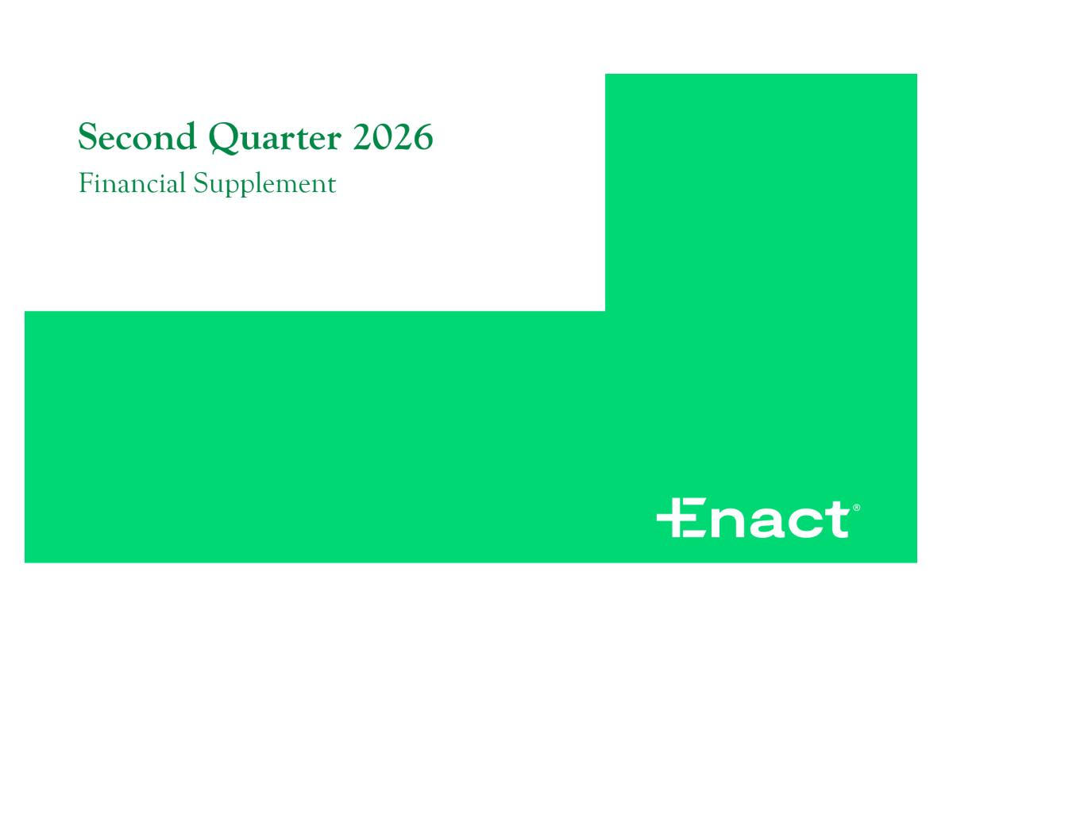
6

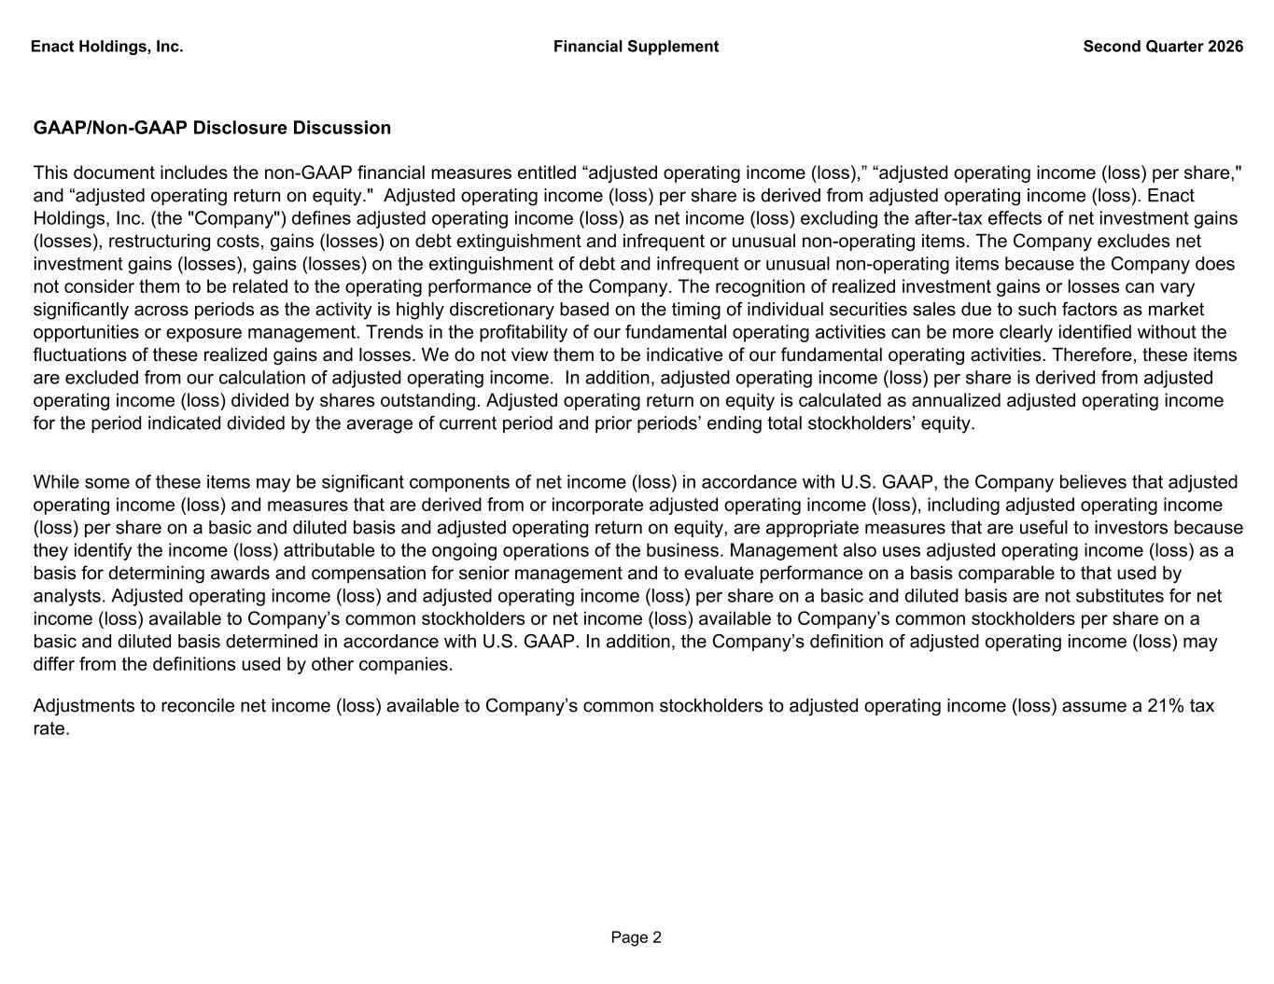
Enact Holdings, Inc. Financial Supplement Second Quarter 2026 GAAP/Non-GAAP Disclosure Discussion This document includes the non-GAAP financial measures entitled “adjusted operating income (loss),” “adjusted operating income (loss) per share," and “adjusted operating return on equity." Adjusted operating income (loss) per share is derived from adjusted operating income (loss). Enact Holdings, Inc. (the "Company") defines adjusted operating income (loss) as net income (loss) excluding the after-tax effects of net investment gains (losses), restructuring costs, gains (losses) on debt extinguishment and infrequent or unusual non-operating items. The Company excludes net investment gains (losses), gains (losses) on the extinguishment of debt and infrequent or unusual non-operating items because the Company does not consider them to be related to the operating performance of the Company. The recognition of realized investment gains or losses can vary significantly across periods as the activity is highly discretionary based on the timing of individual securities sales due to such factors as market opportunities or exposure management. Trends in the profitability of our fundamental operating activities can be more clearly identified without the fluctuations of these realized gains and losses. We do not view them to be indicative of our fundamental operating activities. Therefore, these items are excluded from our calculation of adjusted operating income. In addition, adjusted operating income (loss) per share is derived from adjusted operating income (loss) divided by shares outstanding. Adjusted operating return on equity is calculated as annualized adjusted operating income for the period indicated divided by the average of current period and prior periods’ ending total stockholders’ equity. While some of these items may be significant components of net income (loss) in accordance with U.S. GAAP, the Company believes that adjusted operating income (loss) and measures that are derived from or incorporate adjusted operating income (loss), including adjusted operating income (loss) per share on a basic and diluted basis and adjusted operating return on equity, are appropriate measures that are useful to investors because they identify the income (loss) attributable to the ongoing operations of the business. Management also uses adjusted operating income (loss) as a basis for determining awards and compensation for senior management and to evaluate performance on a basis comparable to that used by analysts. Adjusted operating income (loss) and adjusted operating income (loss) per share on a basic and diluted basis are not substitutes for net income (loss) available to Company’s common stockholders or net income (loss) available to Company’s common stockholders per share on a basic and diluted basis determined in accordance with U.S. GAAP. In addition, the Company’s definition of adjusted operating income (loss) may differ from the definitions used by other companies. Adjustments to reconcile net income (loss) available to Company’s common stockholders to adjusted operating income (loss) assume a 21% tax rate. Page 2

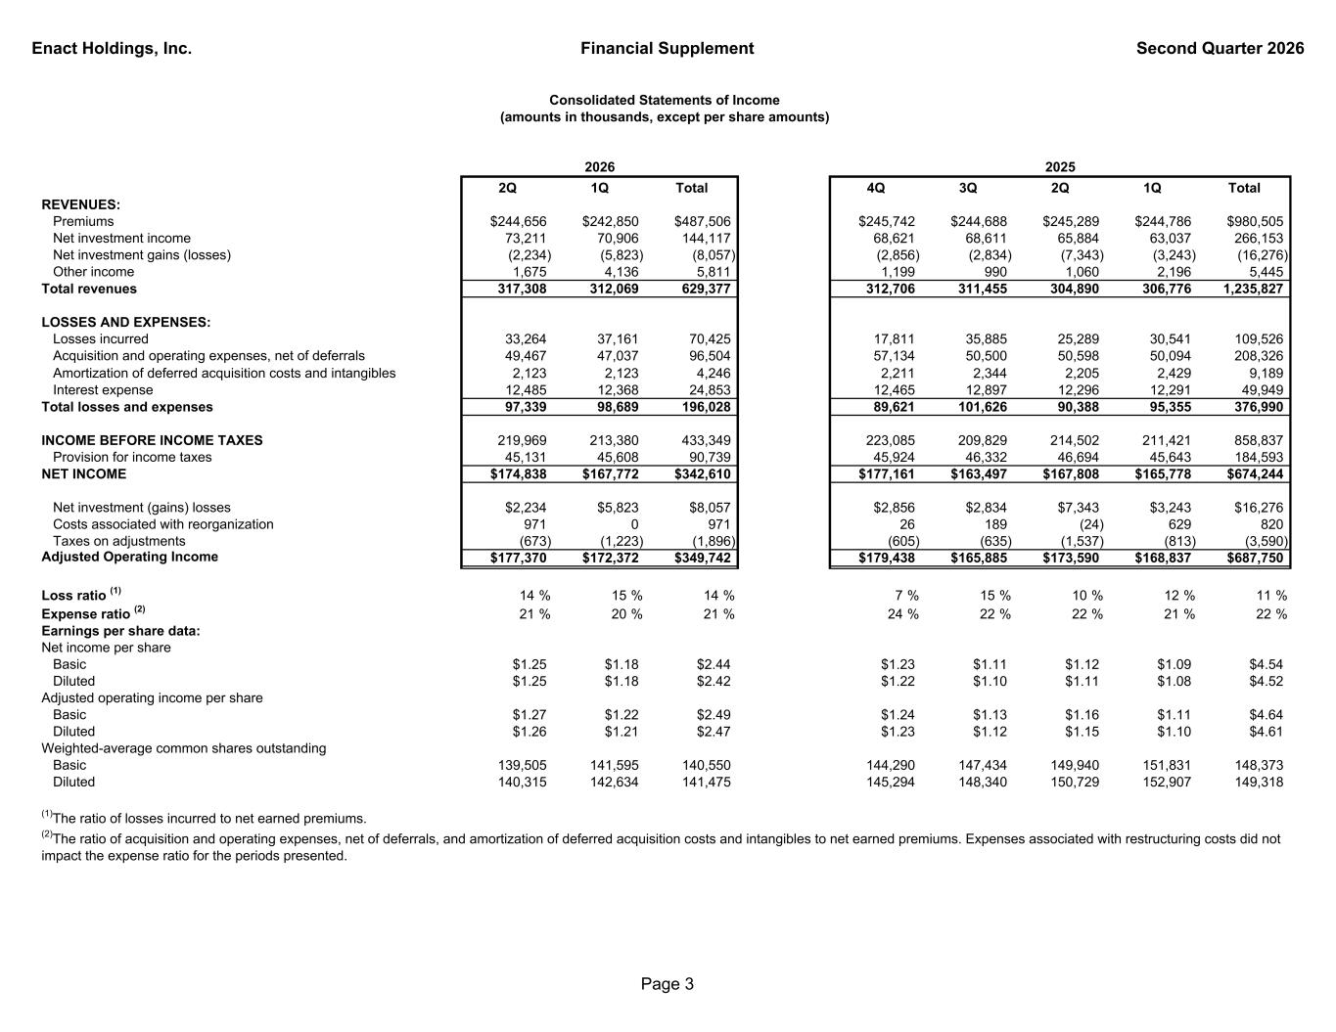
Enact Holdings, Inc. Financial Supplement Second Quarter 2026 2Q 1Q Total 4Q 3Q 2Q 1Q Total REVENUES: Premiums $244,656 $242,850 $487,506 $245,742 $244,688 $245,289 $244,786 $980,505 Net investment income 73,211 70,906 144,117 68,621 68,611 65,884 63,037 266,153 Net investment gains (losses) (2,234) (5,823) (8,057) (2,856) (2,834) (7,343) (3,243) (16,276) Other income 1,675 4,136 5,811 1,199 990 1,060 2,196 5,445 Total revenues 317,308 312,069 629,377 312,706 311,455 304,890 306,776 1,235,827 LOSSES AND EXPENSES: Losses incurred 33,264 37,161 70,425 17,811 35,885 25,289 30,541 109,526 Acquisition and operating expenses, net of deferrals 49,467 47,037 96,504 57,134 50,500 50,598 50,094 208,326 Amortization of deferred acquisition costs and intangibles 2,123 2,123 4,246 2,211 2,344 2,205 2,429 9,189 Interest expense 12,485 12,368 24,853 12,465 12,897 12,296 12,291 49,949 Total losses and expenses 97,339 98,689 196,028 89,621 101,626 90,388 95,355 376,990 INCOME BEFORE INCOME TAXES 219,969 213,380 433,349 223,085 209,829 214,502 211,421 858,837 Provision for income taxes 45,131 45,608 90,739 45,924 46,332 46,694 45,643 184,593 NET INCOME $174,838 $167,772 $342,610 $177,161 $163,497 $167,808 $165,778 $674,244 Net investment (gains) losses $2,234 $5,823 $8,057 $2,856 $2,834 $7,343 $3,243 $16,276 Costs associated with reorganization 971 0 971 26 189 (24) 629 820 Taxes on adjustments (673) (1,223) (1,896) (605) (635) (1,537) (813) (3,590) Adjusted Operating Income $177,370 $172,372 $349,742 $179,438 $165,885 $173,590 $168,837 $687,750 Loss ratio (1) 14 % 15 % 14 % 7 % 15 % 10 % 12 % 11 % Expense ratio (2) 21 % 20 % 21 % 24 % 22 % 22 % 21 % 22 % Earnings per share data: Net income per share Basic $1.25 $1.18 $2.44 $1.23 $1.11 $1.12 $1.09 $4.54 Diluted $1.25 $1.18 $2.42 $1.22 $1.10 $1.11 $1.08 $4.52 Adjusted operating income per share Basic $1.27 $1.22 $2.49 $1.24 $1.13 $1.16 $1.11 $4.64 Diluted $1.26 $1.21 $2.47 $1.23 $1.12 $1.15 $1.10 $4.61 Weighted-average common shares outstanding Basic 139,505 141,595 140,550 144,290 147,434 149,940 151,831 148,373 Diluted 140,315 142,634 141,475 145,294 148,340 150,729 152,907 149,318 (2)The ratio of acquisition and operating expenses, net of deferrals, and amortization of deferred acquisition costs and intangibles to net earned premiums. Expenses associated with restructuring costs did not impact the expense ratio for the periods presented. 2025 (1)The ratio of losses incurred to net earned premiums. Consolidated Statements of Income (amounts in thousands, except per share amounts) 2026 Page 3

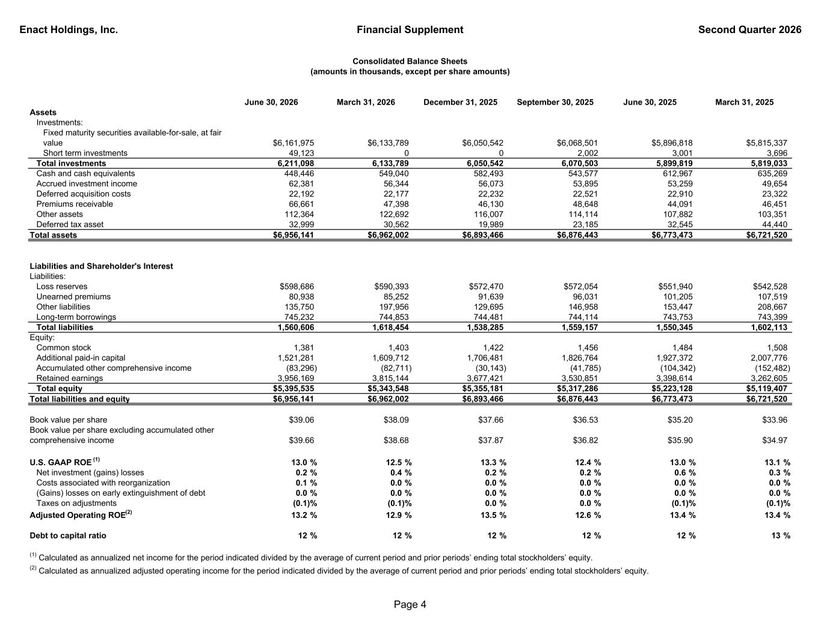
Enact Holdings, Inc. Financial Supplement Second Quarter 2026 June 30, 2026 March 31, 2026 December 31, 2025 September 30, 2025 June 30, 2025 March 31, 2025 Assets Investments: Fixed maturity securities available-for-sale, at fair value $6,161,975 $6,133,789 $6,050,542 $6,068,501 $5,896,818 $5,815,337 Short term investments 49,123 0 0 2,002 3,001 3,696 Total investments 6,211,098 6,133,789 6,050,542 6,070,503 5,899,819 5,819,033 Cash and cash equivalents 448,446 549,040 582,493 543,577 612,967 635,269 Accrued investment income 62,381 56,344 56,073 53,895 53,259 49,654 Deferred acquisition costs 22,192 22,177 22,232 22,521 22,910 23,322 Premiums receivable 66,661 47,398 46,130 48,648 44,091 46,451 Other assets 112,364 122,692 116,007 114,114 107,882 103,351 Deferred tax asset 32,999 30,562 19,989 23,185 32,545 44,440 Total assets $6,956,141 $6,962,002 $6,893,466 $6,876,443 $6,773,473 $6,721,520 Liabilities and Shareholder's Interest Liabilities: Loss reserves $598,686 $590,393 $572,470 $572,054 $551,940 $542,528 Unearned premiums 80,938 85,252 91,639 96,031 101,205 107,519 Other liabilities 135,750 197,956 129,695 146,958 153,447 208,667 Long-term borrowings 745,232 744,853 744,481 744,114 743,753 743,399 Total liabilities 1,560,606 1,618,454 1,538,285 1,559,157 1,550,345 1,602,113 Equity: Common stock 1,381 1,403 1,422 1,456 1,484 1,508 Additional paid-in capital 1,521,281 1,609,712 1,706,481 1,826,764 1,927,372 2,007,776 Accumulated other comprehensive income (83,296) (82,711) (30,143) (41,785) (104,342) (152,482) Retained earnings 3,956,169 3,815,144 3,677,421 3,530,851 3,398,614 3,262,605 Total equity $5,395,535 $5,343,548 $5,355,181 $5,317,286 $5,223,128 $5,119,407 Total liabilities and equity $6,956,141 $6,962,002 $6,893,466 $6,876,443 $6,773,473 $6,721,520 Book value per share $39.06 $38.09 $37.66 $36.53 $35.20 $33.96 Book value per share excluding accumulated other comprehensive income $39.66 $38.68 $37.87 $36.82 $35.90 $34.97 U.S. GAAP ROE (1) 13.0 % 12.5 % 13.3 % 12.4 % 13.0 % 13.1 % Net investment (gains) losses 0.2 % 0.4 % 0.2 % 0.2 % 0.6 % 0.3 % Costs associated with reorganization 0.1 % 0.0 % 0.0 % 0.0 % 0.0 % 0.0 % (Gains) losses on early extinguishment of debt 0.0 % 0.0 % 0.0 % 0.0 % 0.0 % 0.0 % Taxes on adjustments (0.1)% (0.1)% 0.0 % 0.0 % (0.1)% (0.1)% Adjusted Operating ROE(2) 13.2 % 12.9 % 13.5 % 12.6 % 13.4 % 13.4 % Debt to capital ratio 12 % 12 % 12 % 12 % 12 % 13 % (2) Calculated as annualized adjusted operating income for the period indicated divided by the average of current period and prior periods’ ending total stockholders’ equity. (1) Calculated as annualized net income for the period indicated divided by the average of current period and prior periods’ ending total stockholders’ equity. Consolidated Balance Sheets (amounts in thousands, except per share amounts) Page 4

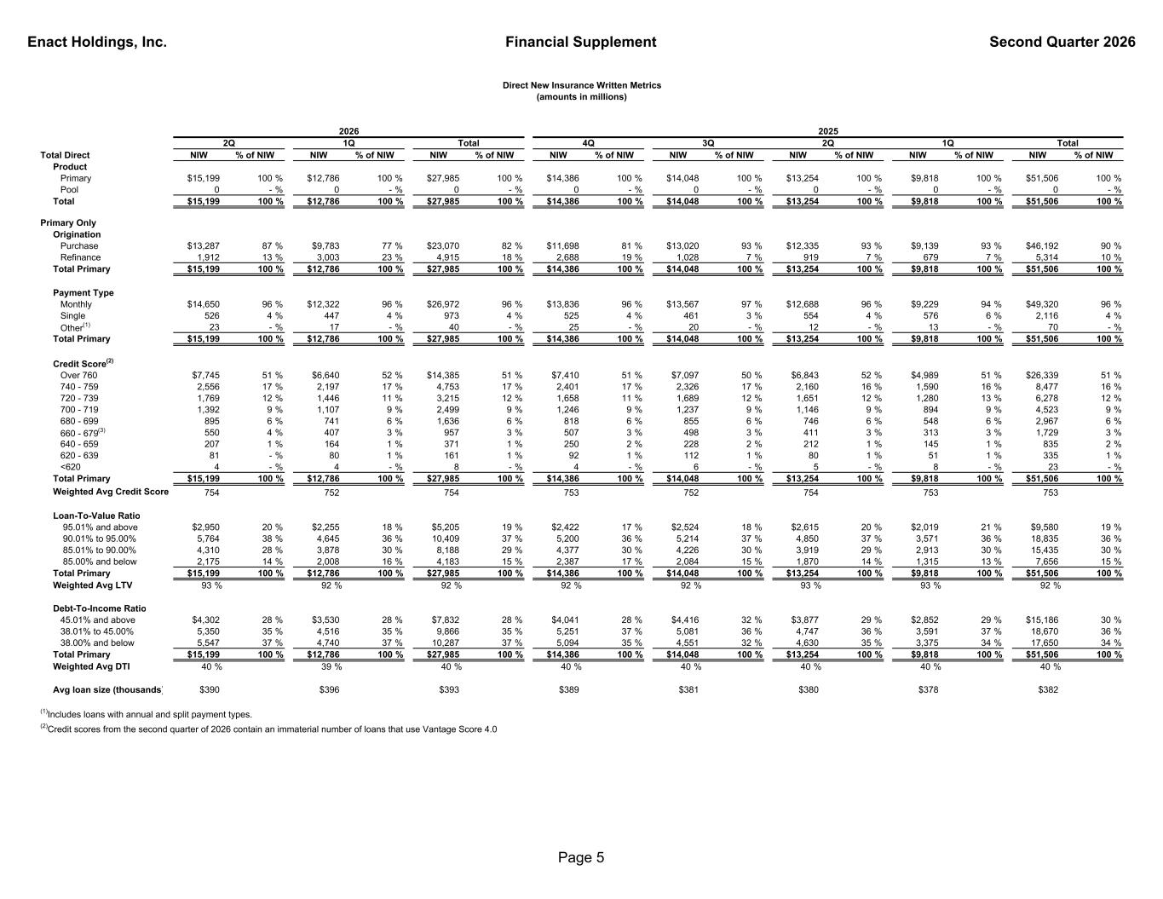
Enact Holdings, Inc. Financial Supplement Second Quarter 2026 Total Direct NIW % of NIW NIW % of NIW NIW % of NIW NIW % of NIW NIW % of NIW NIW % of NIW NIW % of NIW NIW % of NIW Product Primary $15,199 100 % $12,786 100 % $27,985 100 % $14,386 100 % $14,048 100 % $13,254 100 % $9,818 100 % $51,506 100 % Pool 0 - % 0 - % 0 - % 0 - % 0 - % 0 - % 0 - % 0 - % Total $15,199 100 % $12,786 100 % $27,985 100 % $14,386 100 % $14,048 100 % $13,254 100 % $9,818 100 % $51,506 100 % Primary Only Origination Purchase $13,287 87 % $9,783 77 % $23,070 82 % $11,698 81 % $13,020 93 % $12,335 93 % $9,139 93 % $46,192 90 % Refinance 1,912 13 % 3,003 23 % 4,915 18 % 2,688 19 % 1,028 7 % 919 7 % 679 7 % 5,314 10 % Total Primary $15,199 100 % $12,786 100 % $27,985 100 % $14,386 100 % $14,048 100 % $13,254 100 % $9,818 100 % $51,506 100 % Payment Type Monthly $14,650 96 % $12,322 96 % $26,972 96 % $13,836 96 % $13,567 97 % $12,688 96 % $9,229 94 % $49,320 96 % Single 526 4 % 447 4 % 973 4 % 525 4 % 461 3 % 554 4 % 576 6 % 2,116 4 % Other(1) 23 - % 17 - % 40 - % 25 - % 20 - % 12 - % 13 - % 70 - % Total Primary $15,199 100 % $12,786 100 % $27,985 100 % $14,386 100 % $14,048 100 % $13,254 100 % $9,818 100 % $51,506 100 % Credit Score(2) Over 760 $7,745 51 % $6,640 52 % $14,385 51 % $7,410 51 % $7,097 50 % $6,843 52 % $4,989 51 % $26,339 51 % 740 - 759 2,556 17 % 2,197 17 % 4,753 17 % 2,401 17 % 2,326 17 % 2,160 16 % 1,590 16 % 8,477 16 % 720 - 739 1,769 12 % 1,446 11 % 3,215 12 % 1,658 11 % 1,689 12 % 1,651 12 % 1,280 13 % 6,278 12 % 700 - 719 1,392 9 % 1,107 9 % 2,499 9 % 1,246 9 % 1,237 9 % 1,146 9 % 894 9 % 4,523 9 % 680 - 699 895 6 % 741 6 % 1,636 6 % 818 6 % 855 6 % 746 6 % 548 6 % 2,967 6 % 660 - 679(3) 550 4 % 407 3 % 957 3 % 507 3 % 498 3 % 411 3 % 313 3 % 1,729 3 % 640 - 659 207 1 % 164 1 % 371 1 % 250 2 % 228 2 % 212 1 % 145 1 % 835 2 % 620 - 639 81 - % 80 1 % 161 1 % 92 1 % 112 1 % 80 1 % 51 1 % 335 1 % <620 4 - % 4 - % 8 - % 4 - % 6 - % 5 - % 8 - % 23 - % Total Primary $15,199 100 % $12,786 100 % $27,985 100 % $14,386 100 % $14,048 100 % $13,254 100 % $9,818 100 % $51,506 100 % Weighted Avg Credit Score 754 752 754 753 752 754 753 753 Loan-To-Value Ratio 95.01% and above $2,950 20 % $2,255 18 % $5,205 19 % $2,422 17 % $2,524 18 % $2,615 20 % $2,019 21 % $9,580 19 % 90.01% to 95.00% 5,764 38 % 4,645 36 % 10,409 37 % 5,200 36 % 5,214 37 % 4,850 37 % 3,571 36 % 18,835 36 % 85.01% to 90.00% 4,310 28 % 3,878 30 % 8,188 29 % 4,377 30 % 4,226 30 % 3,919 29 % 2,913 30 % 15,435 30 % 85.00% and below 2,175 14 % 2,008 16 % 4,183 15 % 2,387 17 % 2,084 15 % 1,870 14 % 1,315 13 % 7,656 15 % Total Primary $15,199 100 % $12,786 100 % $27,985 100 % $14,386 100 % $14,048 100 % $13,254 100 % $9,818 100 % $51,506 100 % Weighted Avg LTV 93 % 92 % 92 % 92 % 92 % 93 % 93 % 92 % Debt-To-Income Ratio 45.01% and above $4,302 28 % $3,530 28 % $7,832 28 % $4,041 28 % $4,416 32 % $3,877 29 % $2,852 29 % $15,186 30 % 38.01% to 45.00% 5,350 35 % 4,516 35 % 9,866 35 % 5,251 37 % 5,081 36 % 4,747 36 % 3,591 37 % 18,670 36 % 38.00% and below 5,547 37 % 4,740 37 % 10,287 37 % 5,094 35 % 4,551 32 % 4,630 35 % 3,375 34 % 17,650 34 % Total Primary $15,199 100 % $12,786 100 % $27,985 100 % $14,386 100 % $14,048 100 % $13,254 100 % $9,818 100 % $51,506 100 % Weighted Avg DTI 40 % 39 % 40 % 40 % 40 % 40 % 40 % 40 % Avg loan size (thousands) $390 $396 $393 $389 $381 $380 $378 $382 Direct New Insurance Written Metrics (amounts in millions) 3Q Total1Q2Q 2025 4QTotal2Q 1Q 2026 (2)Credit scores from the second quarter of 2026 contain an immaterial number of loans that use Vantage Score 4.0 (1)Includes loans with annual and split payment types. Page 5

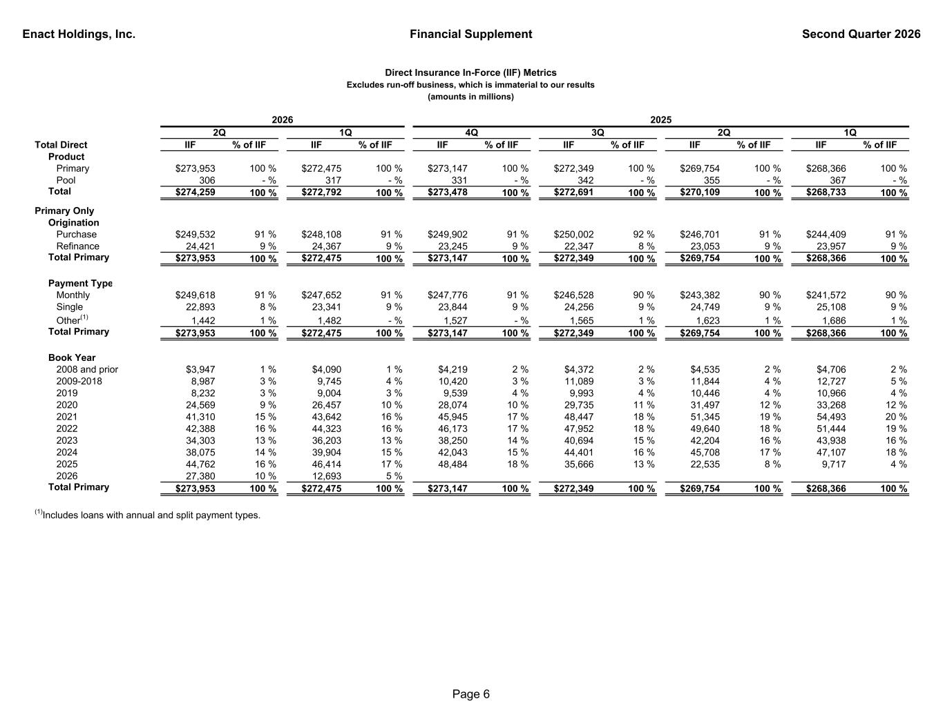
Enact Holdings, Inc. Financial Supplement Second Quarter 2026 Total Direct IIF % of IIF IIF % of IIF IIF % of IIF IIF % of IIF IIF % of IIF IIF % of IIF Product Primary $273,953 100 % $272,475 100 % $273,147 100 % $272,349 100 % $269,754 100 % $268,366 100 % Pool 306 - % 317 - % 331 - % 342 - % 355 - % 367 - % Total $274,259 100 % $272,792 100 % $273,478 100 % $272,691 100 % $270,109 100 % $268,733 100 % Primary Only Origination Purchase $249,532 91 % $248,108 91 % $249,902 91 % $250,002 92 % $246,701 91 % $244,409 91 % Refinance 24,421 9 % 24,367 9 % 23,245 9 % 22,347 8 % 23,053 9 % 23,957 9 % Total Primary $273,953 100 % $272,475 100 % $273,147 100 % $272,349 100 % $269,754 100 % $268,366 100 % Payment Type Monthly $249,618 91 % $247,652 91 % $247,776 91 % $246,528 90 % $243,382 90 % $241,572 90 % Single 22,893 8 % 23,341 9 % 23,844 9 % 24,256 9 % 24,749 9 % 25,108 9 % Other(1) 1,442 1 % 1,482 - % 1,527 - % 1,565 1 % 1,623 1 % 1,686 1 % Total Primary $273,953 100 % $272,475 100 % $273,147 100 % $272,349 100 % $269,754 100 % $268,366 100 % Book Year 2008 and prior $3,947 1 % $4,090 1 % $4,219 2 % $4,372 2 % $4,535 2 % $4,706 2 % 2009-2018 8,987 3 % 9,745 4 % 10,420 3 % 11,089 3 % 11,844 4 % 12,727 5 % 2019 8,232 3 % 9,004 3 % 9,539 4 % 9,993 4 % 10,446 4 % 10,966 4 % 2020 24,569 9 % 26,457 10 % 28,074 10 % 29,735 11 % 31,497 12 % 33,268 12 % 2021 41,310 15 % 43,642 16 % 45,945 17 % 48,447 18 % 51,345 19 % 54,493 20 % 2022 42,388 16 % 44,323 16 % 46,173 17 % 47,952 18 % 49,640 18 % 51,444 19 % 2023 34,303 13 % 36,203 13 % 38,250 14 % 40,694 15 % 42,204 16 % 43,938 16 % 2024 38,075 14 % 39,904 15 % 42,043 15 % 44,401 16 % 45,708 17 % 47,107 18 % 2025 44,762 16 % 46,414 17 % 48,484 18 % 35,666 13 % 22,535 8 % 9,717 4 % 2026 27,380 10 % 12,693 5 % Total Primary $273,953 100 % $272,475 100 % $273,147 100 % $272,349 100 % $269,754 100 % $268,366 100 % (1)Includes loans with annual and split payment types. 4Q 3Q1Q Direct Insurance In-Force (IIF) Metrics Excludes run-off business, which is immaterial to our results (amounts in millions) 1Q 2025 2Q2Q 2026 Page 6

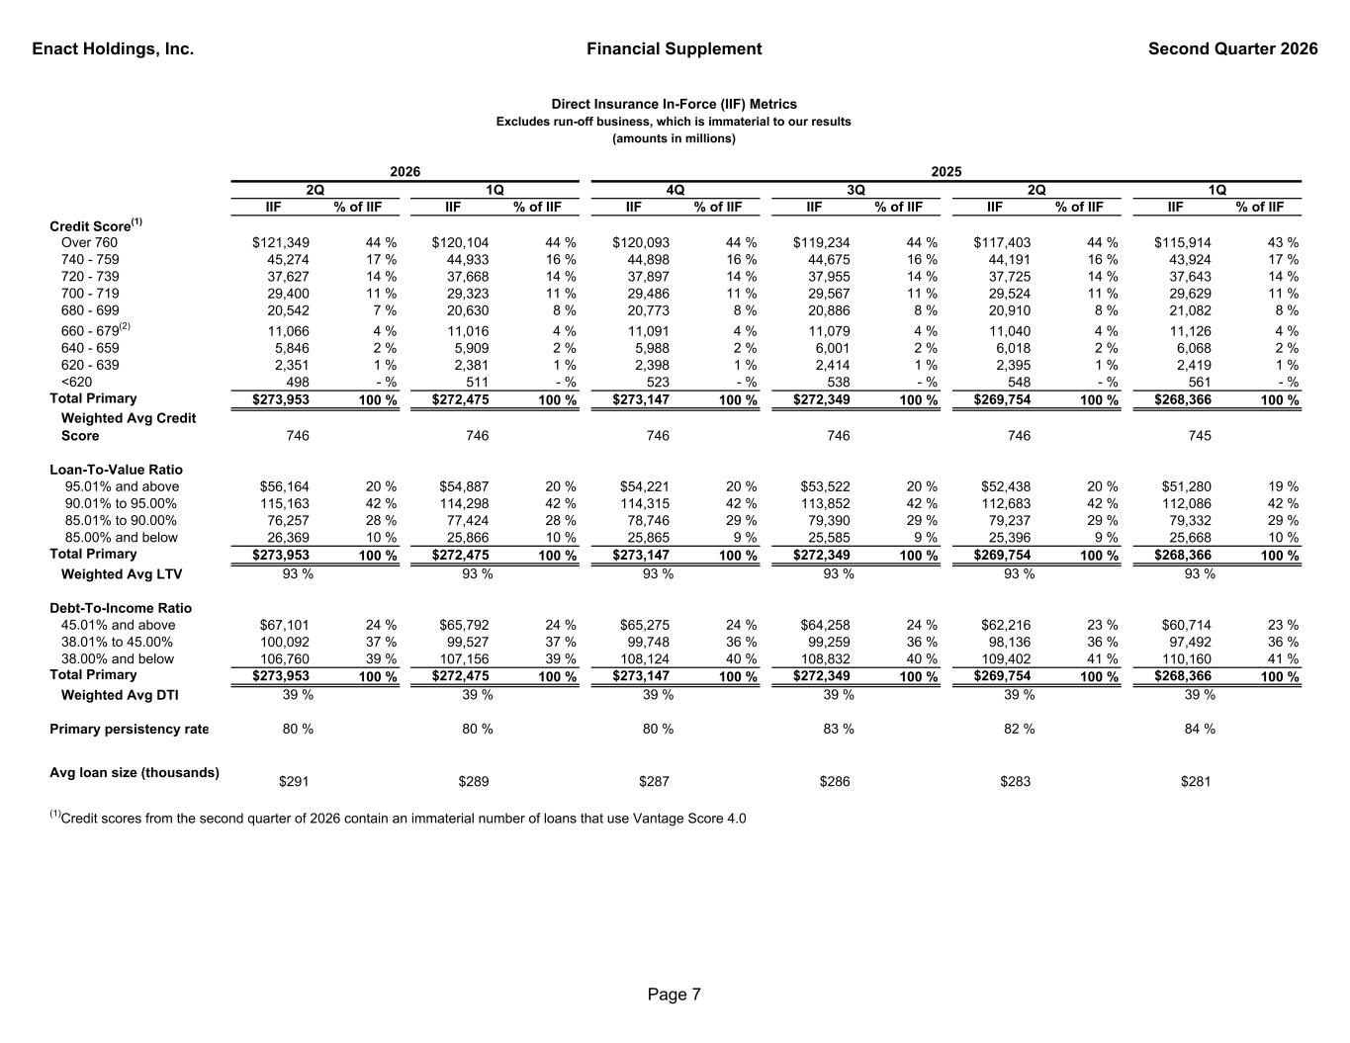
Enact Holdings, Inc. Financial Supplement Second Quarter 2026 IIF % of IIF IIF % of IIF IIF % of IIF IIF % of IIF IIF % of IIF IIF % of IIF Credit Score(1) Over 760 $121,349 44 % $120,104 44 % $120,093 44 % $119,234 44 % $117,403 44 % $115,914 43 % 740 - 759 45,274 17 % 44,933 16 % 44,898 16 % 44,675 16 % 44,191 16 % 43,924 17 % 720 - 739 37,627 14 % 37,668 14 % 37,897 14 % 37,955 14 % 37,725 14 % 37,643 14 % 700 - 719 29,400 11 % 29,323 11 % 29,486 11 % 29,567 11 % 29,524 11 % 29,629 11 % 680 - 699 20,542 7 % 20,630 8 % 20,773 8 % 20,886 8 % 20,910 8 % 21,082 8 % 660 - 679(2) 11,066 4 % 11,016 4 % 11,091 4 % 11,079 4 % 11,040 4 % 11,126 4 % 640 - 659 5,846 2 % 5,909 2 % 5,988 2 % 6,001 2 % 6,018 2 % 6,068 2 % 620 - 639 2,351 1 % 2,381 1 % 2,398 1 % 2,414 1 % 2,395 1 % 2,419 1 % <620 498 - % 511 - % 523 - % 538 - % 548 - % 561 - % Total Primary $273,953 100 % $272,475 100 % $273,147 100 % $272,349 100 % $269,754 100 % $268,366 100 % Weighted Avg Credit Score 746 746 746 746 746 745 Loan-To-Value Ratio 95.01% and above $56,164 20 % $54,887 20 % $54,221 20 % $53,522 20 % $52,438 20 % $51,280 19 % 90.01% to 95.00% 115,163 42 % 114,298 42 % 114,315 42 % 113,852 42 % 112,683 42 % 112,086 42 % 85.01% to 90.00% 76,257 28 % 77,424 28 % 78,746 29 % 79,390 29 % 79,237 29 % 79,332 29 % 85.00% and below 26,369 10 % 25,866 10 % 25,865 9 % 25,585 9 % 25,396 9 % 25,668 10 % Total Primary $273,953 100 % $272,475 100 % $273,147 100 % $272,349 100 % $269,754 100 % $268,366 100 % Weighted Avg LTV 93 % 93 % 93 % 93 % 93 % 93 % Debt-To-Income Ratio 45.01% and above $67,101 24 % $65,792 24 % $65,275 24 % $64,258 24 % $62,216 23 % $60,714 23 % 38.01% to 45.00% 100,092 37 % 99,527 37 % 99,748 36 % 99,259 36 % 98,136 36 % 97,492 36 % 38.00% and below 106,760 39 % 107,156 39 % 108,124 40 % 108,832 40 % 109,402 41 % 110,160 41 % Total Primary $273,953 100 % $272,475 100 % $273,147 100 % $272,349 100 % $269,754 100 % $268,366 100 % Weighted Avg DTI 39 % 39 % 39 % 39 % 39 % 39 % Primary persistency rate 80 % 80 % 80 % 83 % 82 % 84 % Avg loan size (thousands) $291 $289 $287 $286 $283 $281 (1)Credit scores from the second quarter of 2026 contain an immaterial number of loans that use Vantage Score 4.0 4Q1Q Direct Insurance In-Force (IIF) Metrics Excludes run-off business, which is immaterial to our results (amounts in millions) 1Q2Q 2025 3Q2Q 2026 Page 7

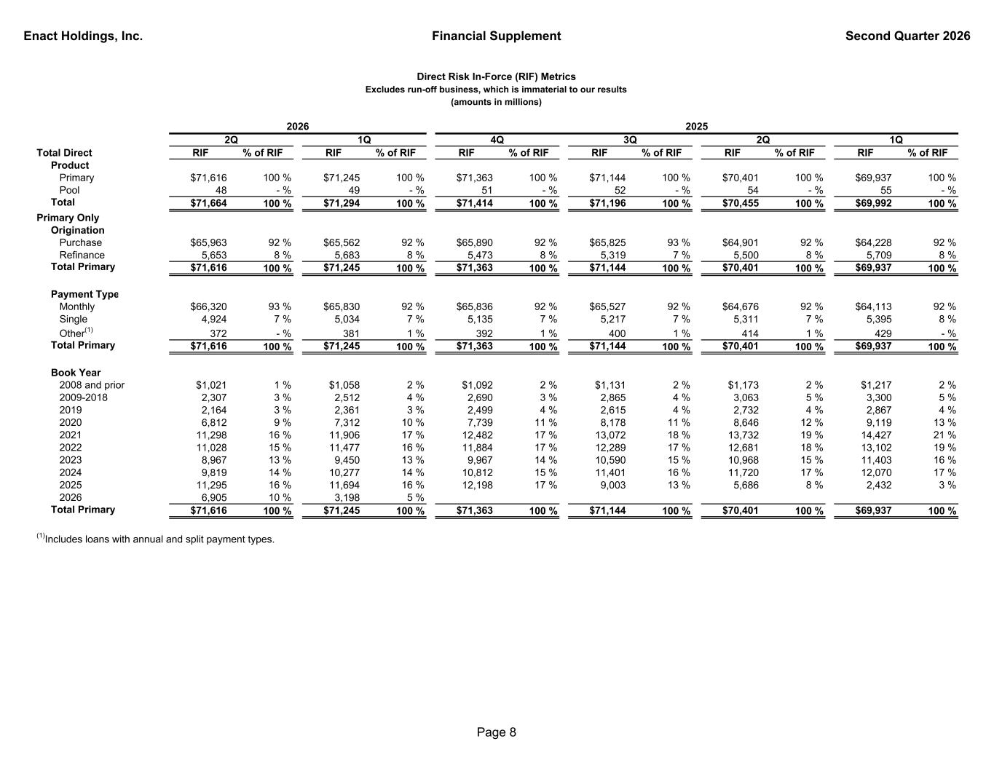
Enact Holdings, Inc. Financial Supplement Second Quarter 2026 Total Direct RIF % of RIF RIF % of RIF RIF % of RIF RIF % of RIF RIF % of RIF RIF % of RIF Product Primary $71,616 100 % $71,245 100 % $71,363 100 % $71,144 100 % $70,401 100 % $69,937 100 % Pool 48 - % 49 - % 51 - % 52 - % 54 - % 55 - % Total $71,664 100 % $71,294 100 % $71,414 100 % $71,196 100 % $70,455 100 % $69,992 100 % Primary Only Origination Purchase $65,963 92 % $65,562 92 % $65,890 92 % $65,825 93 % $64,901 92 % $64,228 92 % Refinance 5,653 8 % 5,683 8 % 5,473 8 % 5,319 7 % 5,500 8 % 5,709 8 % Total Primary $71,616 100 % $71,245 100 % $71,363 100 % $71,144 100 % $70,401 100 % $69,937 100 % Payment Type Monthly $66,320 93 % $65,830 92 % $65,836 92 % $65,527 92 % $64,676 92 % $64,113 92 % Single 4,924 7 % 5,034 7 % 5,135 7 % 5,217 7 % 5,311 7 % 5,395 8 % Other(1) 372 - % 381 1 % 392 1 % 400 1 % 414 1 % 429 - % Total Primary $71,616 100 % $71,245 100 % $71,363 100 % $71,144 100 % $70,401 100 % $69,937 100 % Book Year 2008 and prior $1,021 1 % $1,058 2 % $1,092 2 % $1,131 2 % $1,173 2 % $1,217 2 % 2009-2018 2,307 3 % 2,512 4 % 2,690 3 % 2,865 4 % 3,063 5 % 3,300 5 % 2019 2,164 3 % 2,361 3 % 2,499 4 % 2,615 4 % 2,732 4 % 2,867 4 % 2020 6,812 9 % 7,312 10 % 7,739 11 % 8,178 11 % 8,646 12 % 9,119 13 % 2021 11,298 16 % 11,906 17 % 12,482 17 % 13,072 18 % 13,732 19 % 14,427 21 % 2022 11,028 15 % 11,477 16 % 11,884 17 % 12,289 17 % 12,681 18 % 13,102 19 % 2023 8,967 13 % 9,450 13 % 9,967 14 % 10,590 15 % 10,968 15 % 11,403 16 % 2024 9,819 14 % 10,277 14 % 10,812 15 % 11,401 16 % 11,720 17 % 12,070 17 % 2025 11,295 16 % 11,694 16 % 12,198 17 % 9,003 13 % 5,686 8 % 2,432 3 % 2026 6,905 10 % 3,198 5 % Total Primary $71,616 100 % $71,245 100 % $71,363 100 % $71,144 100 % $70,401 100 % $69,937 100 % (1)Includes loans with annual and split payment types. Direct Risk In-Force (RIF) Metrics Excludes run-off business, which is immaterial to our results (amounts in millions) 1Q2Q4Q 3Q 2025 1Q2Q 2026 Page 8

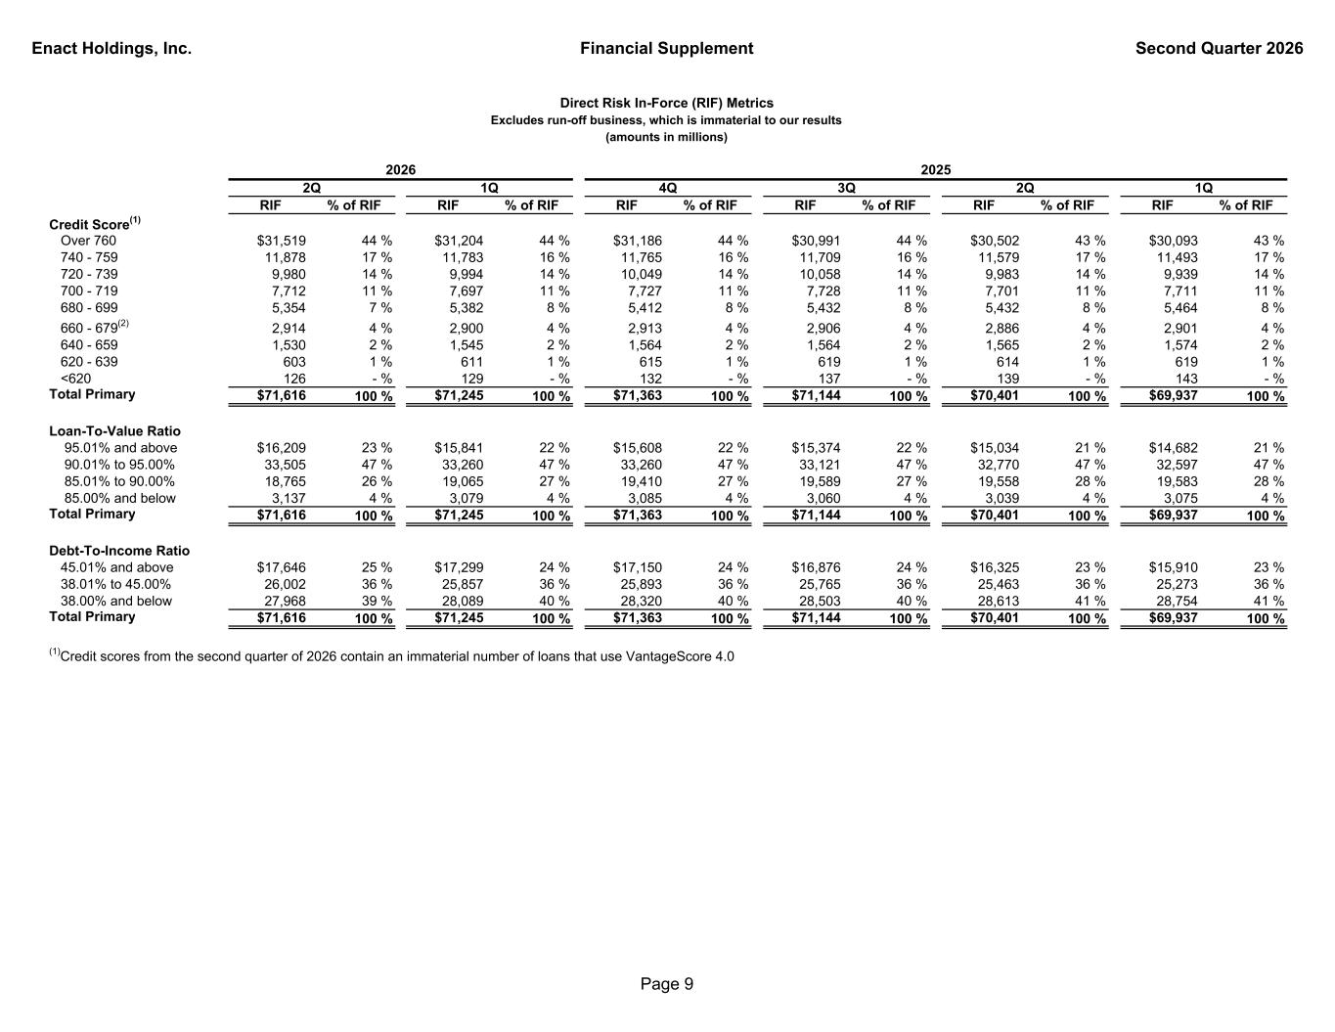
Enact Holdings, Inc. Financial Supplement Second Quarter 2026 RIF % of RIF RIF % of RIF RIF % of RIF RIF % of RIF RIF % of RIF RIF % of RIF Credit Score(1) Over 760 $31,519 44 % $31,204 44 % $31,186 44 % $30,991 44 % $30,502 43 % $30,093 43 % 740 - 759 11,878 17 % 11,783 16 % 11,765 16 % 11,709 16 % 11,579 17 % 11,493 17 % 720 - 739 9,980 14 % 9,994 14 % 10,049 14 % 10,058 14 % 9,983 14 % 9,939 14 % 700 - 719 7,712 11 % 7,697 11 % 7,727 11 % 7,728 11 % 7,701 11 % 7,711 11 % 680 - 699 5,354 7 % 5,382 8 % 5,412 8 % 5,432 8 % 5,432 8 % 5,464 8 % 660 - 679(2) 2,914 4 % 2,900 4 % 2,913 4 % 2,906 4 % 2,886 4 % 2,901 4 % 640 - 659 1,530 2 % 1,545 2 % 1,564 2 % 1,564 2 % 1,565 2 % 1,574 2 % 620 - 639 603 1 % 611 1 % 615 1 % 619 1 % 614 1 % 619 1 % <620 126 - % 129 - % 132 - % 137 - % 139 - % 143 - % Total Primary $71,616 100 % $71,245 100 % $71,363 100 % $71,144 100 % $70,401 100 % $69,937 100 % Loan-To-Value Ratio 95.01% and above $16,209 23 % $15,841 22 % $15,608 22 % $15,374 22 % $15,034 21 % $14,682 21 % 90.01% to 95.00% 33,505 47 % 33,260 47 % 33,260 47 % 33,121 47 % 32,770 47 % 32,597 47 % 85.01% to 90.00% 18,765 26 % 19,065 27 % 19,410 27 % 19,589 27 % 19,558 28 % 19,583 28 % 85.00% and below 3,137 4 % 3,079 4 % 3,085 4 % 3,060 4 % 3,039 4 % 3,075 4 % Total Primary $71,616 100 % $71,245 100 % $71,363 100 % $71,144 100 % $70,401 100 % $69,937 100 % Debt-To-Income Ratio 45.01% and above $17,646 25 % $17,299 24 % $17,150 24 % $16,876 24 % $16,325 23 % $15,910 23 % 38.01% to 45.00% 26,002 36 % 25,857 36 % 25,893 36 % 25,765 36 % 25,463 36 % 25,273 36 % 38.00% and below 27,968 39 % 28,089 40 % 28,320 40 % 28,503 40 % 28,613 41 % 28,754 41 % Total Primary $71,616 100 % $71,245 100 % $71,363 100 % $71,144 100 % $70,401 100 % $69,937 100 % (1)Credit scores from the second quarter of 2026 contain an immaterial number of loans that use VantageScore 4.0 4Q Direct Risk In-Force (RIF) Metrics Excludes run-off business, which is immaterial to our results (amounts in millions) 1Q2Q 2025 3Q1Q2Q 2026 Page 9

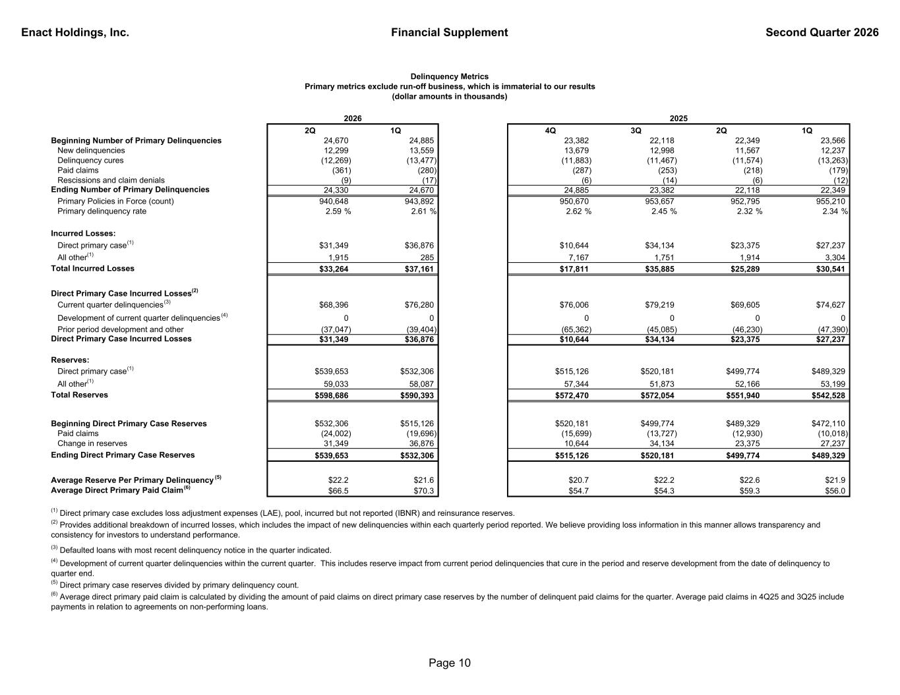
Enact Holdings, Inc. Financial Supplement Second Quarter 2026 2Q 1Q 4Q 3Q 2Q 1Q Beginning Number of Primary Delinquencies 24,670 24,885 23,382 22,118 22,349 23,566 New delinquencies 12,299 13,559 13,679 12,998 11,567 12,237 Delinquency cures (12,269) (13,477) (11,883) (11,467) (11,574) (13,263) Paid claims (361) (280) (287) (253) (218) (179) Rescissions and claim denials (9) (17) (6) (14) (6) (12) Ending Number of Primary Delinquencies 24,330 24,670 24,885 23,382 22,118 22,349 Primary Policies in Force (count) 940,648 943,892 950,670 953,657 952,795 955,210 Primary delinquency rate 2.59 % 2.61 % 2.62 % 2.45 % 2.32 % 2.34 % Incurred Losses: Direct primary case(1) $31,349 $36,876 $10,644 $34,134 $23,375 $27,237 All other(1) 1,915 285 7,167 1,751 1,914 3,304 Total Incurred Losses $33,264 $37,161 $17,811 $35,885 $25,289 $30,541 Direct Primary Case Incurred Losses(2) Current quarter delinquencies(3) $68,396 $76,280 $76,006 $79,219 $69,605 $74,627 Development of current quarter delinquencies (4) 0 0 0 0 0 0 Prior period development and other (37,047) (39,404) (65,362) (45,085) (46,230) (47,390) Direct Primary Case Incurred Losses $31,349 $36,876 $10,644 $34,134 $23,375 $27,237 Reserves: Direct primary case(1) $539,653 $532,306 $515,126 $520,181 $499,774 $489,329 All other(1) 59,033 58,087 57,344 51,873 52,166 53,199 Total Reserves $598,686 $590,393 $572,470 $572,054 $551,940 $542,528 Beginning Direct Primary Case Reserves $532,306 $515,126 $520,181 $499,774 $489,329 $472,110 Paid claims (24,002) (19,696) (15,699) (13,727) (12,930) (10,018) Change in reserves 31,349 36,876 10,644 34,134 23,375 27,237 Ending Direct Primary Case Reserves $539,653 $532,306 $515,126 $520,181 $499,774 $489,329 Average Reserve Per Primary Delinquency (5) $22.2 $21.6 $20.7 $22.2 $22.6 $21.9 Average Direct Primary Paid Claim (6) $66.5 $70.3 $54.7 $54.3 $59.3 $56.0 Delinquency Metrics Primary metrics exclude run-off business, which is immaterial to our results (dollar amounts in thousands) 2025 (5) Direct primary case reserves divided by primary delinquency count. 2026 (6) Average direct primary paid claim is calculated by dividing the amount of paid claims on direct primary case reserves by the number of delinquent paid claims for the quarter. Average paid claims in 4Q25 and 3Q25 include payments in relation to agreements on non-performing loans. (2) Provides additional breakdown of incurred losses, which includes the impact of new delinquencies within each quarterly period reported. We believe providing loss information in this manner allows transparency and consistency for investors to understand performance. (3) Defaulted loans with most recent delinquency notice in the quarter indicated. (1) Direct primary case excludes loss adjustment expenses (LAE), pool, incurred but not reported (IBNR) and reinsurance reserves. (4) Development of current quarter delinquencies within the current quarter. This includes reserve impact from current period delinquencies that cure in the period and reserve development from the date of delinquency to quarter end. Page 10

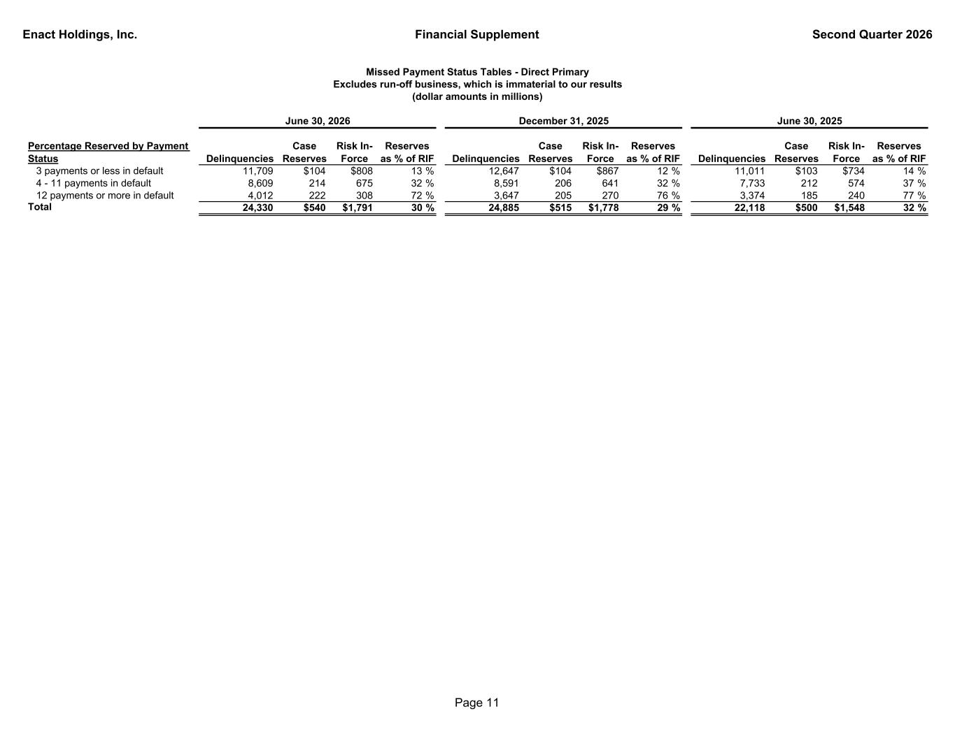
Enact Holdings, Inc. Financial Supplement Second Quarter 2026 Percentage Reserved by Payment Status Delinquencies Case Reserves Risk In- Force Reserves as % of RIF Delinquencies Case Reserves Risk In- Force Reserves as % of RIF Delinquencies Case Reserves Risk In- Force Reserves as % of RIF 3 payments or less in default 11,709 $104 $808 13 % 12,647 $104 $867 12 % 11,011 $103 $734 14 % 4 - 11 payments in default 8,609 214 675 32 % 8,591 206 641 32 % 7,733 212 574 37 % 12 payments or more in default 4,012 222 308 72 % 3,647 205 270 76 % 3,374 185 240 77 % Total 24,330 $540 $1,791 30 % 24,885 $515 $1,778 29 % 22,118 $500 $1,548 32 % June 30, 2026 Missed Payment Status Tables - Direct Primary Excludes run-off business, which is immaterial to our results (dollar amounts in millions) December 31, 2025 June 30, 2025 Page 11

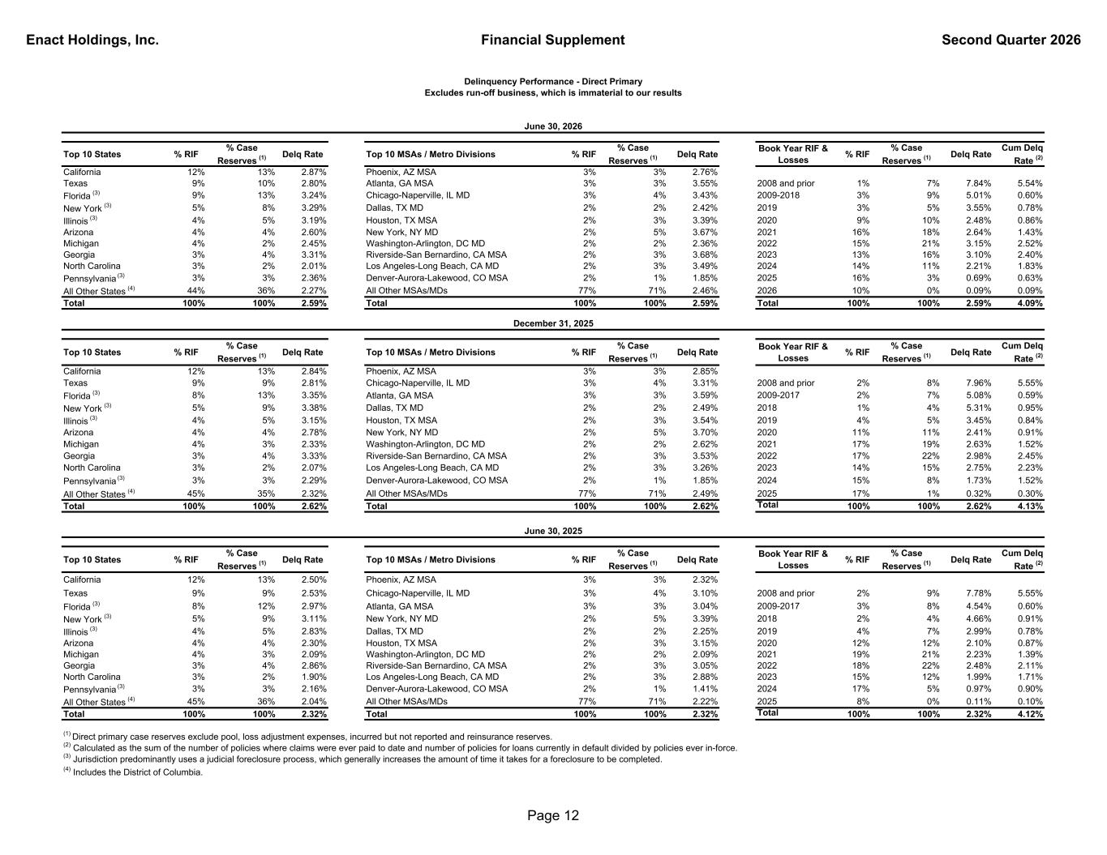
Enact Holdings, Inc. Financial Supplement Second Quarter 2026 Top 10 States % RIF % Case Reserves (1) Delq Rate Top 10 MSAs / Metro Divisions % RIF % Case Reserves (1) Delq Rate Book Year RIF & Losses % RIF % Case Reserves (1) Delq Rate Cum Delq Rate (2) California 12% 13% 2.87% Phoenix, AZ MSA 3% 3% 2.76% Texas 9% 10% 2.80% Atlanta, GA MSA 3% 3% 3.55% 2008 and prior 1% 7% 7.84% 5.54% Florida (3) 9% 13% 3.24% Chicago-Naperville, IL MD 3% 4% 3.43% 2009-2018 3% 9% 5.01% 0.60% New York (3) 5% 8% 3.29% Dallas, TX MD 2% 2% 2.42% 2019 3% 5% 3.55% 0.78% Illinois (3) 4% 5% 3.19% Houston, TX MSA 2% 3% 3.39% 2020 9% 10% 2.48% 0.86% Arizona 4% 4% 2.60% New York, NY MD 2% 5% 3.67% 2021 16% 18% 2.64% 1.43% Michigan 4% 2% 2.45% Washington-Arlington, DC MD 2% 2% 2.36% 2022 15% 21% 3.15% 2.52% Georgia 3% 4% 3.31% Riverside-San Bernardino, CA MSA 2% 3% 3.68% 2023 13% 16% 3.10% 2.40% North Carolina 3% 2% 2.01% Los Angeles-Long Beach, CA MD 2% 3% 3.49% 2024 14% 11% 2.21% 1.83% Pennsylvania (3) 3% 3% 2.36% Denver-Aurora-Lakewood, CO MSA 2% 1% 1.85% 2025 16% 3% 0.69% 0.63% All Other States (4) 44% 36% 2.27% All Other MSAs/MDs 77% 71% 2.46% 2026 10% 0% 0.09% 0.09% Total 100% 100% 2.59% Total 100% 100% 2.59% Total 100% 100% 2.59% 4.09% Top 10 States % RIF % Case Reserves (1) Delq Rate Top 10 MSAs / Metro Divisions % RIF % Case Reserves (1) Delq Rate Book Year RIF & Losses % RIF % Case Reserves (1) Delq Rate Cum Delq Rate (2) California 12% 13% 2.84% Phoenix, AZ MSA 3% 3% 2.85% Texas 9% 9% 2.81% Chicago-Naperville, IL MD 3% 4% 3.31% 2008 and prior 2% 8% 7.96% 5.55% Florida (3) 8% 13% 3.35% Atlanta, GA MSA 3% 3% 3.59% 2009-2017 2% 7% 5.08% 0.59% New York (3) 5% 9% 3.38% Dallas, TX MD 2% 2% 2.49% 2018 1% 4% 5.31% 0.95% Illinois (3) 4% 5% 3.15% Houston, TX MSA 2% 3% 3.54% 2019 4% 5% 3.45% 0.84% Arizona 4% 4% 2.78% New York, NY MD 2% 5% 3.70% 2020 11% 11% 2.41% 0.91% Michigan 4% 3% 2.33% Washington-Arlington, DC MD 2% 2% 2.62% 2021 17% 19% 2.63% 1.52% Georgia 3% 4% 3.33% Riverside-San Bernardino, CA MSA 2% 3% 3.53% 2022 17% 22% 2.98% 2.45% North Carolina 3% 2% 2.07% Los Angeles-Long Beach, CA MD 2% 3% 3.26% 2023 14% 15% 2.75% 2.23% Pennsylvania (3) 3% 3% 2.29% Denver-Aurora-Lakewood, CO MSA 2% 1% 1.85% 2024 15% 8% 1.73% 1.52% All Other States (4) 45% 35% 2.32% All Other MSAs/MDs 77% 71% 2.49% 2025 17% 1% 0.32% 0.30% Total 100% 100% 2.62% Total 100% 100% 2.62% Total 100% 100% 2.62% 4.13% Top 10 States % RIF % Case Reserves (1) Delq Rate Top 10 MSAs / Metro Divisions % RIF % Case Reserves (1) Delq Rate Book Year RIF & Losses % RIF % Case Reserves (1) Delq Rate Cum Delq Rate (2) California 12% 13% 2.50% Phoenix, AZ MSA 3% 3% 2.32% Texas 9% 9% 2.53% Chicago-Naperville, IL MD 3% 4% 3.10% 2008 and prior 2% 9% 7.78% 5.55% Florida (3) 8% 12% 2.97% Atlanta, GA MSA 3% 3% 3.04% 2009-2017 3% 8% 4.54% 0.60% New York (3) 5% 9% 3.11% New York, NY MD 2% 5% 3.39% 2018 2% 4% 4.66% 0.91% Illinois (3) 4% 5% 2.83% Dallas, TX MD 2% 2% 2.25% 2019 4% 7% 2.99% 0.78% Arizona 4% 4% 2.30% Houston, TX MSA 2% 3% 3.15% 2020 12% 12% 2.10% 0.87% Michigan 4% 3% 2.09% Washington-Arlington, DC MD 2% 2% 2.09% 2021 19% 21% 2.23% 1.39% Georgia 3% 4% 2.86% Riverside-San Bernardino, CA MSA 2% 3% 3.05% 2022 18% 22% 2.48% 2.11% North Carolina 3% 2% 1.90% Los Angeles-Long Beach, CA MD 2% 3% 2.88% 2023 15% 12% 1.99% 1.71% Pennsylvania (3) 3% 3% 2.16% Denver-Aurora-Lakewood, CO MSA 2% 1% 1.41% 2024 17% 5% 0.97% 0.90% All Other States (4) 45% 36% 2.04% All Other MSAs/MDs 77% 71% 2.22% 2025 8% 0% 0.11% 0.10% Total 100% 100% 2.32% Total 100% 100% 2.32% Total 100% 100% 2.32% 4.12% (1) Direct primary case reserves exclude pool, loss adjustment expenses, incurred but not reported and reinsurance reserves. (2) Calculated as the sum of the number of policies where claims were ever paid to date and number of policies for loans currently in default divided by policies ever in-force. (3) Jurisdiction predominantly uses a judicial foreclosure process, which generally increases the amount of time it takes for a foreclosure to be completed. (4) Includes the District of Columbia. Delinquency Performance - Direct Primary Excludes run-off business, which is immaterial to our results June 30, 2026 June 30, 2025 December 31, 2025 Page 12

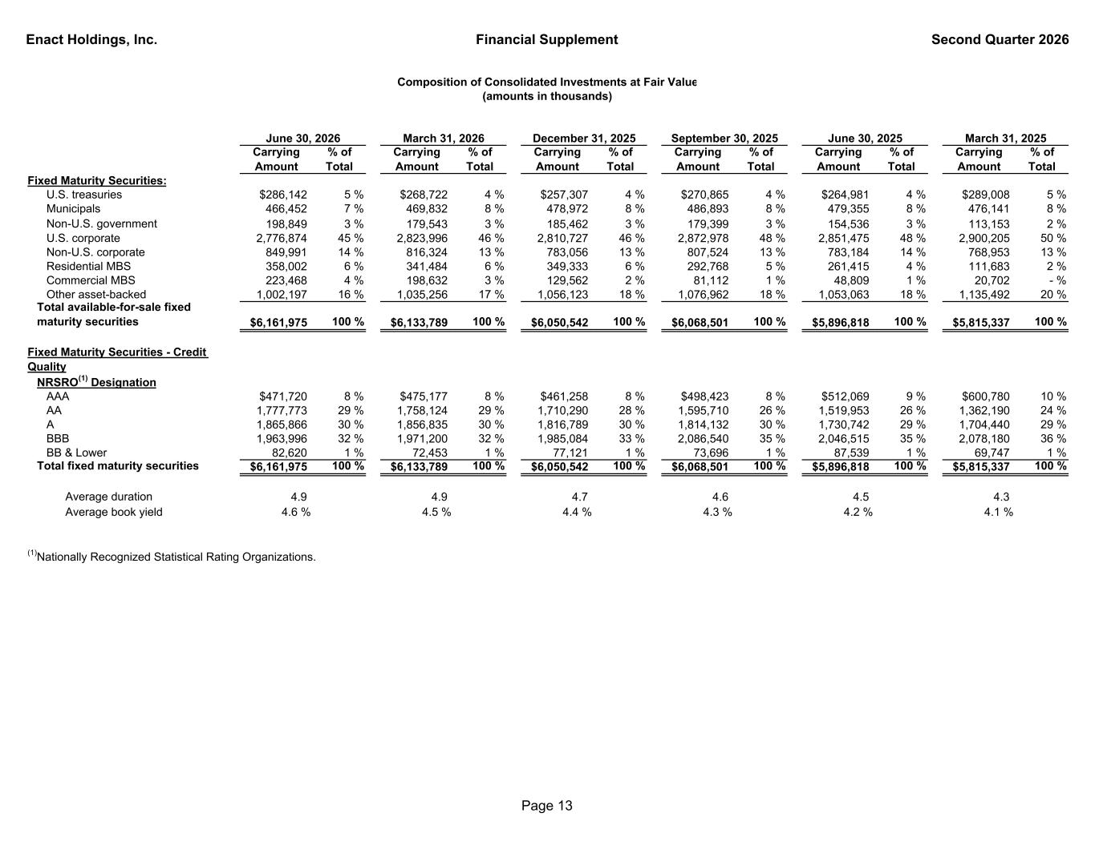
Enact Holdings, Inc. Financial Supplement Second Quarter 2026 Carrying Amount % of Total Carrying Amount % of Total Carrying Amount % of Total Carrying Amount % of Total Carrying Amount % of Total Carrying Amount % of Total Fixed Maturity Securities: U.S. treasuries $286,142 5 % $268,722 4 % $257,307 4 % $270,865 4 % $264,981 4 % $289,008 5 % Municipals 466,452 7 % 469,832 8 % 478,972 8 % 486,893 8 % 479,355 8 % 476,141 8 % Non-U.S. government 198,849 3 % 179,543 3 % 185,462 3 % 179,399 3 % 154,536 3 % 113,153 2 % U.S. corporate 2,776,874 45 % 2,823,996 46 % 2,810,727 46 % 2,872,978 48 % 2,851,475 48 % 2,900,205 50 % Non-U.S. corporate 849,991 14 % 816,324 13 % 783,056 13 % 807,524 13 % 783,184 14 % 768,953 13 % Residential MBS 358,002 6 % 341,484 6 % 349,333 6 % 292,768 5 % 261,415 4 % 111,683 2 % Commercial MBS 223,468 4 % 198,632 3 % 129,562 2 % 81,112 1 % 48,809 1 % 20,702 - % Other asset-backed 1,002,197 16 % 1,035,256 17 % 1,056,123 18 % 1,076,962 18 % 1,053,063 18 % 1,135,492 20 % Total available-for-sale fixed maturity securities $6,161,975 100 % $6,133,789 100 % $6,050,542 100 % $6,068,501 100 % $5,896,818 100 % $5,815,337 100 % Fixed Maturity Securities - Credit Quality NRSRO(1) Designation AAA $471,720 8 % $475,177 8 % $461,258 8 % $498,423 8 % $512,069 9 % $600,780 10 % AA 1,777,773 29 % 1,758,124 29 % 1,710,290 28 % 1,595,710 26 % 1,519,953 26 % 1,362,190 24 % A 1,865,866 30 % 1,856,835 30 % 1,816,789 30 % 1,814,132 30 % 1,730,742 29 % 1,704,440 29 % BBB 1,963,996 32 % 1,971,200 32 % 1,985,084 33 % 2,086,540 35 % 2,046,515 35 % 2,078,180 36 % BB & Lower 82,620 1 % 72,453 1 % 77,121 1 % 73,696 1 % 87,539 1 % 69,747 1 % Total fixed maturity securities $6,161,975 100 % $6,133,789 100 % $6,050,542 100 % $6,068,501 100 % $5,896,818 100 % $5,815,337 100 % Average duration 4.9 4.9 4.7 4.6 4.5 4.3 Average book yield 4.6 % 4.5 % 4.4 % 4.3 % 4.2 % 4.1 % (1)Nationally Recognized Statistical Rating Organizations. December 31, 2025 September 30, 2025 Composition of Consolidated Investments at Fair Value (amounts in thousands) March 31, 2025June 30, 2025March 31, 2026June 30, 2026 Page 13

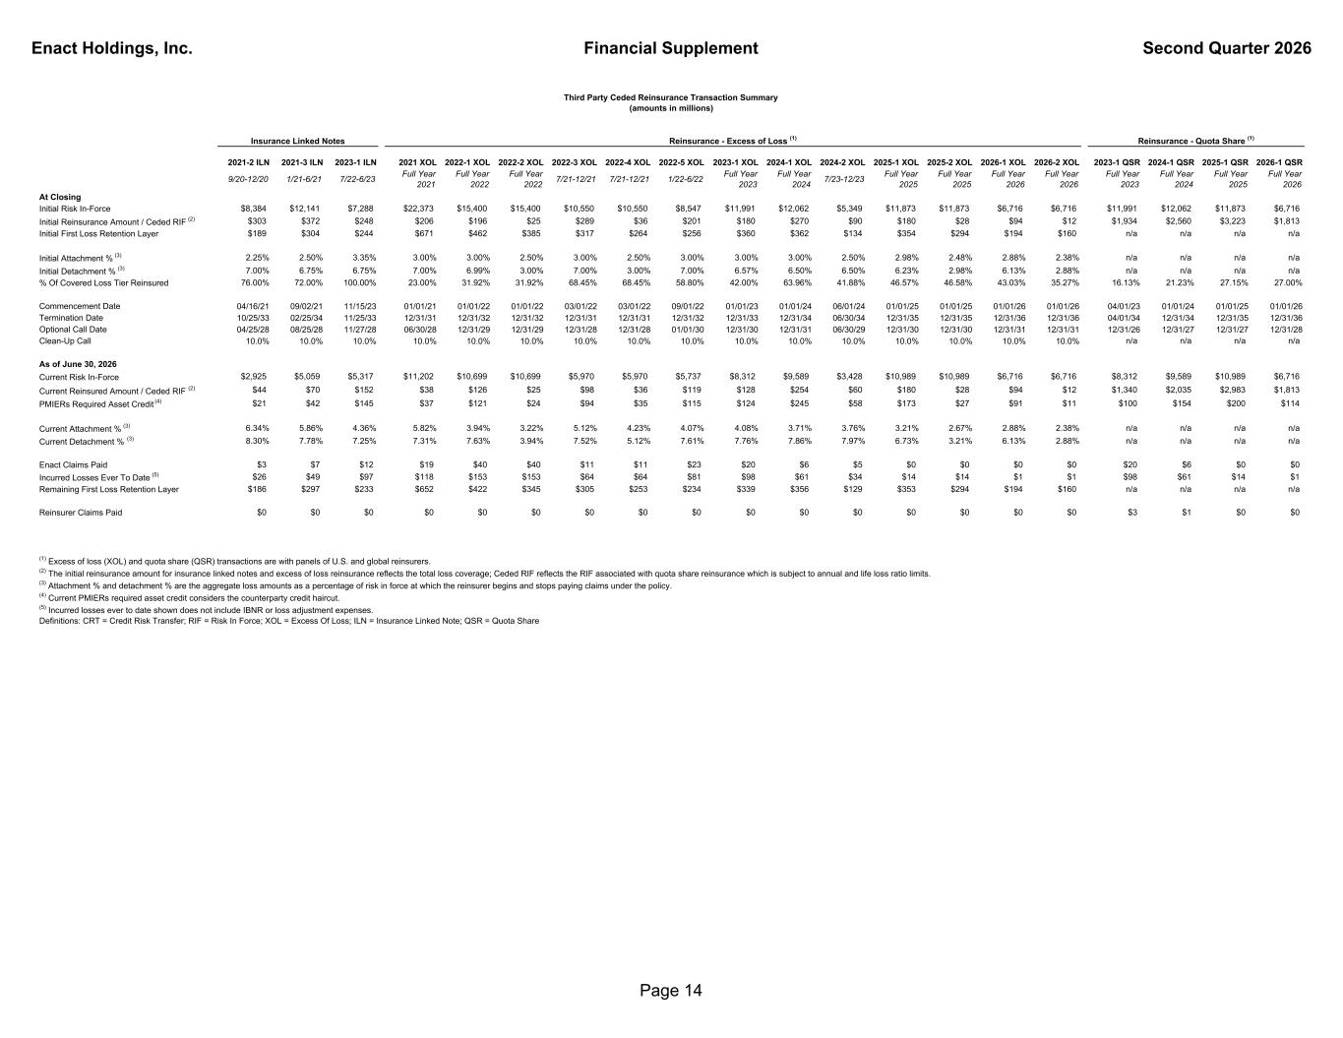
Enact Holdings, Inc. Financial Supplement Second Quarter 2026 2021-2 ILN 2021-3 ILN 2023-1 ILN 2021 XOL 2022-1 XOL 2022-2 XOL 2022-3 XOL 2022-4 XOL 2022-5 XOL 2023-1 XOL 2024-1 XOL 2024-2 XOL 2025-1 XOL 2025-2 XOL 2026-1 XOL 2026-2 XOL 2023-1 QSR 2024-1 QSR 2025-1 QSR 2026-1 QSR 9/20-12/20 1/21-6/21 7/22-6/23 Full Year 2021 Full Year 2022 Full Year 2022 7/21-12/21 7/21-12/21 1/22-6/22 Full Year 2023 Full Year 2024 7/23-12/23 Full Year 2025 Full Year 2025 Full Year 2026 Full Year 2026 Full Year 2023 Full Year 2024 Full Year 2025 Full Year 2026 At Closing Initial Risk In-Force $8,384 $12,141 $7,288 $22,373 $15,400 $15,400 $10,550 $10,550 $8,547 $11,991 $12,062 $5,349 $11,873 $11,873 $6,716 $6,716 $11,991 $12,062 $11,873 $6,716 Initial Reinsurance Amount / Ceded RIF (2) $303 $372 $248 $206 $196 $25 $289 $36 $201 $180 $270 $90 $180 $28 $94 $12 $1,934 $2,560 $3,223 $1,813 Initial First Loss Retention Layer $189 $304 $244 $671 $462 $385 $317 $264 $256 $360 $362 $134 $354 $294 $194 $160 n/a n/a n/a n/a Initial Attachment % (3) 2.25% 2.50% 3.35% 3.00% 3.00% 2.50% 3.00% 2.50% 3.00% 3.00% 3.00% 2.50% 2.98% 2.48% 2.88% 2.38% n/a n/a n/a n/a Initial Detachment % (3) 7.00% 6.75% 6.75% 7.00% 6.99% 3.00% 7.00% 3.00% 7.00% 6.57% 6.50% 6.50% 6.23% 2.98% 6.13% 2.88% n/a n/a n/a n/a % Of Covered Loss Tier Reinsured 76.00% 72.00% 100.00% 23.00% 31.92% 31.92% 68.45% 68.45% 58.80% 42.00% 63.96% 41.88% 46.57% 46.58% 43.03% 35.27% 16.13% 21.23% 27.15% 27.00% Commencement Date 04/16/21 09/02/21 11/15/23 01/01/21 01/01/22 01/01/22 03/01/22 03/01/22 09/01/22 01/01/23 01/01/24 06/01/24 01/01/25 01/01/25 01/01/26 01/01/26 04/01/23 01/01/24 01/01/25 01/01/26 Termination Date 10/25/33 02/25/34 11/25/33 12/31/31 12/31/32 12/31/32 12/31/31 12/31/31 12/31/32 12/31/33 12/31/34 06/30/34 12/31/35 12/31/35 12/31/36 12/31/36 04/01/34 12/31/34 12/31/35 12/31/36 Optional Call Date 04/25/28 08/25/28 11/27/28 06/30/28 12/31/29 12/31/29 12/31/28 12/31/28 01/01/30 12/31/30 12/31/31 06/30/29 12/31/30 12/31/30 12/31/31 12/31/31 12/31/26 12/31/27 12/31/27 12/31/28 Clean-Up Call 10.0% 10.0% 10.0% 10.0% 10.0% 10.0% 10.0% 10.0% 10.0% 10.0% 10.0% 10.0% 10.0% 10.0% 10.0% 10.0% n/a n/a n/a n/a As of June 30, 2026 Current Risk In-Force $2,925 $5,059 $5,317 $11,202 $10,699 $10,699 $5,970 $5,970 $5,737 $8,312 $9,589 $3,428 $10,989 $10,989 $6,716 $6,716 $8,312 $9,589 $10,989 $6,716 Current Reinsured Amount / Ceded RIF (2) $44 $70 $152 $38 $126 $25 $98 $36 $119 $128 $254 $60 $180 $28 $94 $12 $1,340 $2,035 $2,983 $1,813 PMIERs Required Asset Credit (4) $21 $42 $145 $37 $121 $24 $94 $35 $115 $124 $245 $58 $173 $27 $91 $11 $100 $154 $200 $114 Current Attachment % (3) 6.34% 5.86% 4.36% 5.82% 3.94% 3.22% 5.12% 4.23% 4.07% 4.08% 3.71% 3.76% 3.21% 2.67% 2.88% 2.38% n/a n/a n/a n/a Current Detachment % (3) 8.30% 7.78% 7.25% 7.31% 7.63% 3.94% 7.52% 5.12% 7.61% 7.76% 7.86% 7.97% 6.73% 3.21% 6.13% 2.88% n/a n/a n/a n/a Enact Claims Paid $3 $7 $12 $19 $40 $40 $11 $11 $23 $20 $6 $5 $0 $0 $0 $0 $20 $6 $0 $0 Incurred Losses Ever To Date (5) $26 $49 $97 $118 $153 $153 $64 $64 $81 $98 $61 $34 $14 $14 $1 $1 $98 $61 $14 $1 Remaining First Loss Retention Layer $186 $297 $233 $652 $422 $345 $305 $253 $234 $339 $356 $129 $353 $294 $194 $160 n/a n/a n/a n/a Reinsurer Claims Paid $0 $0 $0 $0 $0 $0 $0 $0 $0 $0 $0 $0 $0 $0 $0 $0 $3 $1 $0 $0 Third Party Ceded Reinsurance Transaction Summary (amounts in millions) (1) Excess of loss (XOL) and quota share (QSR) transactions are with panels of U.S. and global reinsurers. (2) The initial reinsurance amount for insurance linked notes and excess of loss reinsurance reflects the total loss coverage; Ceded RIF reflects the RIF associated with quota share reinsurance which is subject to annual and life loss ratio limits. (3) Attachment % and detachment % are the aggregate loss amounts as a percentage of risk in force at which the reinsurer begins and stops paying claims under the policy. (4) Current PMIERs required asset credit considers the counterparty credit haircut. (5) Incurred losses ever to date shown does not include IBNR or loss adjustment expenses. Definitions: CRT = Credit Risk Transfer; RIF = Risk In Force; XOL = Excess Of Loss; ILN = Insurance Linked Note; QSR = Quota Share Reinsurance - Excess of Loss (1) Reinsurance - Quota Share (1)Insurance Linked Notes Page 14

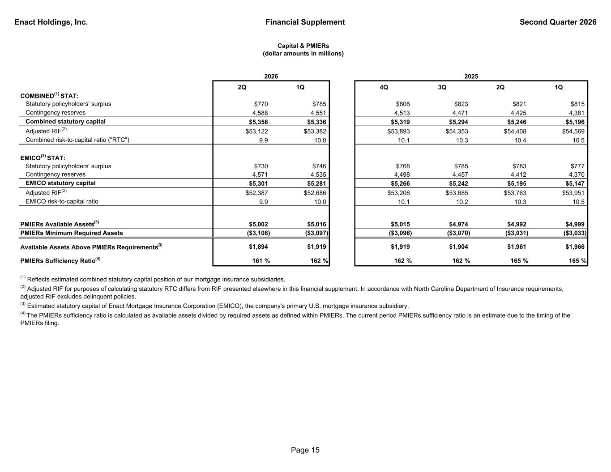
Enact Holdings, Inc. Financial Supplement Second Quarter 2026 2Q 1Q 4Q 3Q 2Q 1Q COMBINED(1) STAT: Statutory policyholders' surplus $770 $785 $806 $823 $821 $815 Contingency reserves 4,588 4,551 4,513 4,471 4,425 4,381 Combined statutory capital $5,358 $5,336 $5,319 $5,294 $5,246 $5,196 Adjusted RIF(2) $53,122 $53,382 $53,893 $54,353 $54,408 $54,569 Combined risk-to-capital ratio ("RTC") 9.9 10.0 10.1 10.3 10.4 10.5 EMICO(3) STAT: Statutory policyholders' surplus $730 $746 $768 $785 $783 $777 Contingency reserves 4,571 4,535 4,498 4,457 4,412 4,370 EMICO statutory capital $5,301 $5,281 $5,266 $5,242 $5,195 $5,147 Adjusted RIF(2) $52,387 $52,686 $53,206 $53,685 $53,763 $53,951 EMICO risk-to-capital ratio 9.9 10.0 10.1 10.2 10.3 10.5 PMIERs Available Assets(3) $5,002 $5,016 $5,015 $4,974 $4,992 $4,999 PMIERs Minimum Required Assets ($3,108) ($3,097) ($3,096) ($3,070) ($3,031) ($3,033) Available Assets Above PMIERs Requirements(3) $1,894 $1,919 $1,919 $1,904 $1,961 $1,966 PMIERs Sufficiency Ratio(4) 161 % 162 % 162 % 162 % 165 % 165 % (4) The PMIERs sufficiency ratio is calculated as available assets divided by required assets as defined within PMIERs. The current period PMIERs sufficiency ratio is an estimate due to the timing of the PMIERs filing. 2025 Capital & PMIERs (dollar amounts in millions) (3) Estimated statutory capital of Enact Mortgage Insurance Corporation (EMICO), the company's primary U.S. mortgage insurance subsidiary. (1) Reflects estimated combined statutory capital position of our mortgage insurance subsidiaries. (2) Adjusted RIF for purposes of calculating statutory RTC differs from RIF presented elsewhere in this financial supplement. In accordance with North Carolina Department of Insurance requirements, adjusted RIF excludes delinquent policies. 2026 Page 15

